Final Year Design Project
College Management System for Govt Graduate College, Mandi Bahauddin.
Final Year Design Project
By

Hadia | 085668
Syeda Laraib Qamar Kazmi | 085713
Sharfa Kiran | 085646

FYP Advisor: Prof. Ubaid Ullah.

Department of Information Technology,
Govt. Graduate College, Mandi Bahauddin.
College Management System for GGC MBDin.

DECLARATION
We hereby declare that this software, neither the whole nor a part, was copied from any source. It is further declared that we have developed this software and accompanying report based on our efforts. If any part of this project is proven to be copied from any source or found to be a reproduction of some other, we will stand by the consequences. No portion of the work presented has been submitted for any application for any other degree or qualification of this or any other university or institute of learning.

Hadia [084668] Sharfa [085646]
Signature: ______________ Signature: _______________

Syeda Laraib Qamar Kazmi [085713]
Signature: ______________

CERTIFICATE OF APPROVAL
It is to certify that the final year project (FYP) of BSIT, session (2022-26), the project College Management System For Govt Graduate College, Mandi Bahauddin was developed by Hadia (2022-mcm-359), Sharfa (2022-mcm-84), and Syeda Laraib Qamar Kazmi (2022-mcm-37) under the supervision of Prof. Ubaid Ullah Sb. in my opinion; it is fully adequate, in scope and quality for the degree of Bachelors of Science in Information Technology.

FYP Advisor: Prof. Ubaid Ullah Sb.
Advisor Signature: _____________________

Signatures (Faculty Advisory Committee (FAC))
 | FAC1 | FAC2
Name | Prof. Muhammad Faiyaz. | Prof. Ubaid Ullah.
Signature

Head of FYP Coordination Office: Prof. Muhammad Faiyaz Sb.
Signature: ________________________

Head Of Department, Information Technology: Prof. Muhammad Faiyaz Sb.
Signature: _____________________ Dated: __________________

Summary
This project proposes an Android-based College Management System (CMS) for Government Graduate College Mandi Bahauddin, which currently serves around 3,000 students across Intermediate and Bachelor's programs with approximately 50 faculty members. All academic and administrative processes, fee challan generation, attendance, exam paper submission, performance lists, and record management are handled entirely manually, causing long queues, heavy staff workload, delays, and frequent human error.
The proposed solution is a mobile application with three role-based modules for Students, Teachers, and Admin. Students can generate fee challans online, view personal details, check attendance and timetables, track academic progress, and receive notifications all without visiting campus. Teachers can enter midterm and sessional marks, mark attendance digitally, and submit customised exam papers online. Admins can manage student records, import semester data, generate performance reports for all seven BS departments and Intermediate, and oversee the system through a web panel.
The app is built in Java using Android Studio with an MVP architecture. Firebase Firestore handles cloud storage and real-time sync, Firebase Authentication manages secure login, and a local Room database ensures offline access for core features. The project is divided among three team members: Hadia (Admin module), Syeda Laraib Qamar Kazmi (Student module), and Sharfa Kiran (Teacher module) supervised by Prof. Ubaid Ullah. It is initially targeted at GGC MBDin but designed to scale to affiliated colleges across Punjab.

Table of Contents
Summary 4
Chapter 1: Introduction 9
Background 10
Problem Statement 10
Stakeholders & Interests 11
Objectives 12
Scope 13
LITERATURE REVIEW 14
Related Work 14
Gap Analysis 14
FYP OVERVIEW 15
TOOLS, LIBRARIES, AND TECHNOLOGIES WITH REASONING: 18
Work Division 19
Chapter 2: Requirement Analysis 21
User Classes and Characteristics 22
Requirement Identifying Technique 22
Surveys/Questionnaires 22
Ethnography/Observation 23
Use Case Modeling 23
Functional Requirements 23
Functional Requirement 1 23
Functional Requirement 2 24
Functional Requirement 3 25
Functional Requirement 4 25
Functional Requirement 5 26
Functional Requirement 6 27
Functional Requirement 7 27
Functional Requirement 8 28
Functional Requirement 9 28
Functional Requirement 10 29
Functional Requirement 11 30
Functional Requirement 12 30
Functional Requirement 13 31
Functional Requirement 14 32
Functional Requirement 15 32
Functional Requirement 16 33
Functional Requirement 17 33
Functional Requirement 18 34
Non-Functional Requirements 35
Reliability 35
Usability 35
Performance 36
Security 36
Communications Interfaces 37
Use Case Analysis 37
Use Case #1 (Registration) 37
Use Case #2 (Account linking) 39
Use Case #3 (Email verification) 41
Use Case #4 (Login account) 43
Use Case #5 (Reset password) 44
Use Case #5 (Generating fee challan) 46
Use Case #6 (Profile view) 48
Use Case #7 (Account linking) 49
Use Case #8 (Attendance marking) 51
Use Case #9 (Timetable) 52
Use Case #10 (Customized papers) 54
Use Case #11(Profile view of student) 55
Use Case #12 (Inserting marks in lists) 57
Use Case #13 (Allowing admin to manage users) 58
Use Case #14 (Analyzing students attendance) 60
Use Case #15 (Managing students records) 62
Use Case #16 (Sharing Schedule and results) 64
Use Case #17 (Course management) 66
Use Case #18 (progress reports) 68
Use Case Diagram 70
Chapter 3: System Design 73
Design Consideration 74
Assumptions and Dependencies: 74
Risks 74
Requirement Traceability Matrix 75
Design Models 76
Class Diagrams 76
Sequence Diagrams 100
Splash Screen Sequence 101
Registration Sequence 101
Login Sequence 102
Forget Password Sequence 102
Student Account Linking Request 102
Student Challan Form Generation 103
Student Account Approval 103
Architectural Design 103
Component Diagram 104
Class Relationship Diagram 105
Architecture Pattern Diagram 106
Data design 106
Data dictionary 114
Designs Decisions 122
User Interface Design 123
Screen Images 124
Summary 124
References 126

Chapter 1: Introduction

Background
The project falls under the domain of Higher Education Management Systems with a focus on automation and digital transformation for academic institutions. It addresses administrative, educational, and student service processes through a platform. The primary target institution is the Government Graduate College Mandi Bahauddin, which offers multiple Intermediate and bachelor's degree programs across departments such as English, Chemistry, and Physics.
Higher education institutions are shifting towards digitized information systems to improve efficiency, reduce manual workload, and enhance student experience. In Pakistan, however, many public sector colleges still rely on manual processes for admissions, fee challan generation, timetable, attendance, academic record-keeping, and assessment management. This leads to inefficiencies, administrative bottlenecks, and delayed services. The education technology market in Pakistan is expanding, with increasing smartphone usage making mobile solutions a viable approach.
At present, the Government Graduate College Mandi Bahauddin manages processes manually, where fee challan generation is handled by clerks, requiring students to visit in person. Midterm and sessional marks are entered manually on physical performance sheets. Teachers prepare exam papers and submit them physically, leading to delays, and students have no unified online platform to access their personal information, performance reports, or fee details. These inefficiencies result in time wastage, staff workload stress, and reduced operational efficiency. There is no current system that allows students, teachers, and administration to solve these problems.
By introducing a College Management application, the institution can enable students to access challan forms, progress reports, attendance, timetable, and personal data remotely. Allow teachers to enter marks, submit exam papers, and manage assessments online. Provide administration with tools to upload and manage student records digitally, and reduce manual paperwork, queues, and delays. The automation of these tasks will save time, minimize human error, and improve service delivery, benefiting both staff and students while aligning the institution with modern digital education practices.

Problem Statement
Government Graduate College Mandi Bahauddin currently lacks a digital management system for its Intermediate and BS departments. All academic and administrative processes, including admissions, challan generation, attendance, performance list preparation, and record management, are handled manually.
The manual approach is time-consuming, labor-intensive, and prone to human error. Staff experience heavy workloads and increased stress, while teachers face delays in submitting performance lists and examination papers. Students often have to visit the college in person for routine tasks such as generating fee challans or checking academic records, leading to long queues and wasted time.
The core problem is the lack of an Android-based college management application that can automate challan generation, digitize performance list preparation, enable online submission of exam papers, attendance and marks, and provide students with direct access to personal information, academic progress, and notifications.
The college has intermediate and bachelor’s departments and admits a large number of students annually. The institution serves around 3,000 students and employs 50 faculty members. Preparing performance lists for all enrolled students manually consumes several working days per semester and causes repeated delays in submission.

Stakeholders & Interests

Stakeholder | Interest | Market size
Govt. Graduate College,  Mandi Bahauddin. | Automation of the entire manual Intermediate and BS program management system, including admissions, challan generation, result management, and performance list preparation. | 1 institution initially, scalable to 2–3 affiliated colleges per district across Punjab (dozens of potential colleges)
Professors / Teaching Staff | Ability to prepare and submit performance lists online, generate exam papers digitally, and submit them directly to the administration without physical handover. Significant reduction in clerical workload and time spent on manual paperwork. | About 50 teachers in the college, potentially hundreds in other institutions using the same system
Students | Generate challan forms online, avoid long queues, access personal records, progress reports, and receive important notifications directly through the app. Improved convenience and transparency in academic processes. | About 3,000 students in the college, with the potential to serve thousands more in other affiliated colleges

Objectives
- Implement a role-based access control system for students, teachers, and admin staff using an offline room database and online Firebase services, ensuring at least 95% login and permission accuracy in test cases to improve security and user-specific access.
- Enable teachers to update award lists for midterm and sessional marks and submit midterm papers through an online Firebase database, achieving 100% successful synchronization with admin records to streamline academic data management.
- Allow students to view their personal ID details and generate custom fee challan forms from an online semester-updated database, ensuring 98% or higher accuracy in fee data to reduce on-campus queues and manual processing.
- Develop a feature for admin staff to import and update semester student data using SQLite database files prepared in SQLite Browser, maintaining 100% data integrity during the import process to ensure accurate and up-to-date records.
- Implement a students performance report generation module that allows admin staff to compile results for all seven BS departments and intermediate with zero calculation errors, and allow admin to create and upload timetables, and also provide actionable insights for academic decision-making.
- Allow teachers to mark the attendance online and allow students to view their attendance.

Scope
The scope of this project is to design and develop an Android-based platform focused on automation and digital transformation for academic institutions. It addresses administrative, educational, and student service processes through a mobile application.
The project will include:
- A role-based access control system for students, teachers, and admin staff using an offline room database and online Firebase services.
- It allows students to view their personal details and generate custom fee challan forms from an online semester-updated database.
- It develops a feature for admin staff to import and update semester student data using SQLite database files prepared in SQLite Browser.
- It allows teachers to update award lists for midterm and sessional marks and submit midterm papers and attendance marking through an online Firebase Database.
- It allows staff to generate a performance report on every semester's results and for intermediate students.
The project scope excludes the iOS version, and the entire system hasn't been shifted to the cloud, as some things are offline.
Target stakeholders include the Government Graduate College Mandi Bahauddin, Professor/ Teaching staff, and Students.
The development will be divided into milestones:
- Proposal preparation
- ⁠SRS (Software Requirements Specification)
- SDS (Software Design Specification)
- Prototype
- Complete Implementation
- Testing & Deployment

LITERATURE REVIEW

Related Work
Punjab University has an exam result portal. Students can check their results from the portal. Punjab University displays statistical reports of students, but these reports are not specific to any college and show records of all PU Students. Also, provides no offline support.
University of Sargodha has a self-service for generating challan for their students, but they don’t provide students with performance reports, or Personal data tracking. Also, provides no offline support.
Ellucian Student SIS provides fee challan generation, performance reports, mid & sessional marksheet, but their system isn't scalable to localized information and systems. Also, provides no offline support.

Gap Analysis

Common Gap | Impact | Proposed Solution
College-specific statistical report | Each college does not have a proper system for creating a statistical report | Our system provides college-specific statistical report generation
Student personal ID & Performance | It does not store the Student's personal tracking | Our system provides personal tracking
Enterprise scale and costly | Other colleges cannot adopt this system | Our system is scalable compared with others
Offline Capability | The system cannot be accessed remotely | Our system will provide remote and offline capability for challan generation and personal tracking

FYP OVERVIEW
FDP Title: Collage Management System For GGC MBDin

Sr. No | Roll Numbers | Name | Signatures
1. | 085668 | Hadia
2. | 085713 | Syeda Laraib Qamar Kazmi
3. | 085646 | Sharfa Kiran

FYP Goals:
- Provide a mobile platform to manage the functions of Intermediate and BS.
- Enable teachers to update award lists for midterm & sessional marks, submit midterm papers,attendance and generate a performance report for BS and intermediate.
- Provide administration with tools to upload and manage student records and timetables.
- Enhance the system to allow students to access challan forms, progress reports, and personal data, timetable.
- Reduce manual paperwork, queues, delays, and prone to human error.
- A web panel for the admin module.
FYP Objectives:
- Implement a role-based access control system for students, teachers, and admin staff using an offline Room database and Firebase Services, ensuring login and permission accuracy in test cases to improve security and user-specific access.
- Enable teachers to update award lists for midterm and sessional marks and submit midterm papers through an online Firebase database, achieving successful synchronization with admin records to streamline academic data management.
- Allow students to view their personal ID details, attendance, timetable, and generate custom fee challan forms from an online semester-updated database, ensuring higher accuracy in fee data to reduce on-campus queues and manual processing.
- Develop a feature for admin staff to import and update semester student data using the room database database files prepared in SQLite Browser, maintaining data integrity during the import process to ensure accurate and up-to-date records.
- Implement a departmental performance report generation module that allows admin staff to compile results for all seven BS departments and for intermediate with zero calculation errors, and allow admin to create and upload timetables, and also provide actionable insights for academic decision-making.
- Allow teachers to mark the attendance online and allow students to view their attendance.
FYP Success Criteria:
- The system successfully achieves all goals and objectives with accuracy.
- All deliverables will be testable, and the system will pass all test cases.
- If the app is acceptable to all stakeholders, it means our project is successful.
Assumptions:
- It is assumed that the users are using Android devices to access the application.
- It is assumed that the teachers and admin must know how to navigate a basic app.
- It is assumed that the records of students will be updated by the administration in every semester.
- It is assumed that the Firebase services are reliable.
- Features like challan generation, marks submission, and performance analyzer require internet access to work properly.
- It is assumed that the students' data exists in an app for analysis.

Risks & Obstacles:
Risk /obstacles | Impact | Mitigation strategy
The semester-wise data may not be updated on time. | If the data or updates are not received when required, the application may not function properly. This could also lead to errors by clerical staff and may cause delays in processes. | A video tutorial should be created to demonstrate how to enter data into the database, how to prepare it, and how to deploy it. This way, even if the cleric is replaced in the future, they will still have complete guidance on the system and the mechanism of how to perform the tasks.
There may be a lack of flexibility in the mid-term exam paper pattern. | Teachers may feel restricted if they are not allowed to submit customized papers. This could negatively affect their teaching style and also the evaluation of students. | Allow teachers to create customized exam papers, where they can set their own questions and mark distribution.
There may be privacy concerns with the offline database. | Someone could take a file, store it on their personal laptop, and access all student data without proper control. | We will make the database encrypted. Once the database is encrypted, even if someone tries to copy or open the database file, they will not be able to access or read the data due to encryption.

Organizational Address:
Department of Information Technology, Govt. Graduate College, Mandi Bahauddin.
Target End Users:
- Students
- Professors
- College Staff
Project Supervisor: Prof. Ubaid Ullah.
Approved By:
Date:

TOOLS, LIBRARIES, AND TECHNOLOGIES WITH REASONING:

Tools | Version | Rationale
Android Studio | Android version (Narwhal Feature Drop 2025.1.2 Patch 1 - Build 2025.1.12), Gradle version (8.13.x). | We used Android Studio as the main development tool. We used its latest version because it is the official IDE for Android development, also we selected Gradle because it automates the process of compiling multiple files.
java | 17 | We use the Java language primarily because applications were developed in the past entirely using Java, and we need to use Java for backward compatibility. It also helps in resolving technical issues efficiently.
Room Database | 3.50.4 | An Offline database, which is basically a layer above a SQLite database.
Firebase | Web Console | An online database, which will be used for data exchange and authentication.
XML | Default in Android Studio | XML is used for UI design as it is the standard markup language for Android layouts.

Work Division

Sr.No | Roll Number | Name | Role Assignment & Work Division
1. | 085668 | Hadia | Role assignment will be as a Software Engineer.  Work division: Admin Module
2. | 085713 | Syeda Laraib Qamar Kazmi | Role assignment will be as a Software Engineer.  Work division: Student Module
3. | 085646 | Sharfa Kiran | Role assignment will be as a Software Engineer.  Work division: Teachers Module

Chapter 2: Requirement Analysis

User Classes and Characteristics

User Class | User Characteristics
Admin | Admin can insert records of all students, manage databases, generate progress reports of students, provide admission forms, and make time tables. Admin can access the overall system to update, delete, and manage the overall system.
Teachers | Teachers can make customized papers, add marks for all students in performance reports, and mark student attendance. Teachers can access students' records, performance lists, and view students' academic performance.
Students | Students can view their personal IDs, generate customized fee challans, view their academic progress, and get notifications. Students can only access their personal details like ID and marks, etc, and can get and submit admission forms, fee challans.

Requirement Identifying Technique

Surveys/Questionnaires
Surveys or questionnaires are requirements elicitation techniques used to collect information from users and stakeholders about their needs, expectations, and to get their suggestions about the new system. It includes both open-ended (can answer freely) and closed-ended (fixed answers) questions. Surveys and questionnaires used in requirements gathering are used to collect feedback from large numbers of users quickly. To understand the problems faced by users. To get suggestions and what they expect from the system. Surveys and Questionnaires can be done using Google Forms and printed papers.

Ethnography/Observation
In our ethnography project, we are studying a specific field environment. In this environment, we observe how people work, how they interact with each other, and what the main requirements are if we decide to digitize their work processes. Since we are actually part of this environment, we have observed it closely. Through our observations, we have identified several things that should be digitized, certain requirements that need to be met, and some existing problems within the environment that also need to be addressed.

Use Case Modeling
It is a technique that shows the system’s users and their interactions to understand the system’s requirements. Through use case modeling, we define the main actors (such as students, teachers, and administrators) and specify their interactions with the system. Each use case represents a specific function that the system must support, such as logging in or generating challan forms, etc. By creating use case diagrams and descriptions, we are able to clearly identify the system’s functional requirements and ensure that all user needs are properly addressed.

Functional Requirements

Functional Requirement 1

Identifier | FR-1
Title | Register with email
Requirement | The student shall be able to register their account using a valid email address.
Source | The requirement is gathered from students through surveys.
Rationale | To ensure that no unauthorized user can access the system.
Business Rule  (if required) | Email must be valid.
Dependences | FR-2, FR-3
Priority | High

Functional Requirement 2

Identifier | FR-2
Title | Log in with email
Requirement | The student/teacher/admin shall be able to log in to their account if their email is verified.
Source | The requirement is gathered from students through surveys.
Rationale | To ensure that no unauthorized user can access the system.
Business Rule  (if required) | Email must be verified
Dependences | All
Priority | High

Functional Requirement 3

Identifier | FR-3
Title | Reset password using email
Requirement | The student/teacher/admin shall be able to reset their password using email verification.
Source | The requirement is gathered from students through surveys.
Rationale | If a student enters the wrong password, the system allows them to enter the password again.
Business Rule  (if required) | Email must be verified
Dependences | FR-2
Priority | High

Functional Requirement 4

Identifier | FR-4
Title | Account linking using email
Requirement | The student shall be able to link their account to their Student ID, with approval by the admin/teacher.
Source | The requirement is gathered from students through surveys.
Rationale | To ensure that no unauthorized user can access the system.
Business Rule  (if required) | Email must be verified
Dependences | FR-6
Priority | High

Functional Requirement 5

Identifier | FR-5
Title | Challan form generation
Requirement | The student shall be able to generate challan forms for their college fee.
Source | The requirement is gathered from students through surveys.
Rationale | The existing system doesn’t have a challan form generating system. It's a manual system where students write their details on a slip and then a stamp is put on it.
Business Rule  (if required) | None
Dependences | None
Priority | High

Functional Requirement 6

Identifier | FR-6
Title | Personal Detail
Requirement | The student shall be able to view their personal ID details.
Source | The requirement is gathered from students through surveys.
Rationale | To allow students to access and confirm their personal details securely.
Business Rule  (if required) | None
Dependences | None
Priority | High

Functional Requirement 7

Identifier | FR-7
Title | Notifications
Requirement | The student shall be able to receive notifications related to college.
Source | The requirement is gathered from students through surveys.
Rationale | A Notification feature has been added to ensure timely communication from the college to students.
Business Rule  (if required) | None
Dependences | None
Priority | High

Functional Requirement 8

Identifier | FR-8
Title | Enter the Marks in the mark sheet
Requirement | The teachers shall be able to update award lists for midterm and sessional marks.
Source | The requirement is gathered from teachers through surveys.
Rationale | To ensure that teachers can accurately record and update students' marks in the system.
Business Rule  (if required) | None
Dependences | None
Priority | High

Functional Requirement 9

Identifier | FR-9
Title | Mark Attendance by the teacher
Requirement | The teachers shall be able to mark the attendance of students.
Source | The requirement is gathered from teachers through surveys.
Rationale | To mark the attendance of all students digitally instead of manually.
Business Rule  (if required) | None
Dependences | None
Priority | High

Functional Requirement 10

Identifier | FR-10
Title | Manage the timetable
Requirement | The teacher/admin should be able to manage and update their class timetable.
Source | Information collected from teachers through surveys.
Rationale | To make sure teachers can organize their schedules easily.
Business Rule  (if required) | None
Dependences | None
Priority | High

Functional Requirement 11

Identifier | FR-11
Title | Make customized papers
Requirement | The teachers shall be able to mark the attendance of students.
Source | The requirement is gathered from teachers through surveys.
Rationale | To allow teachers to make papers according to their own pattern.
Business Rule  (if required) | The paper submission portal will only open when the admin opens it. Otherwise, it won’t be accessible.
Dependences | None
Priority | High

Functional Requirement 12

Identifier | FR-12
Title | User management
Requirement | The admin shall be able to manage the user's account, like create, edit, delete, and add.
Source | The requirement is gathered from teachers through surveys.
Rationale | To ensure that only authorized users can access the profile and make changes.
Business Rule  (if required) | None
Dependences | None
Priority | High

Functional Requirement 13

Identifier | FR-13
Title | Manage departments
Requirement | The admin should be able to add, update, and delete departments.
Source | The requirement is gathered from teachers through surveys.
Rationale | To keep department data organized and up to date.
Business Rule  (if required) | None
Dependences | None
Priority | High

Functional Requirement 14

Identifier | FR-14
Title | Manage Attendance
Requirement | The admin shall be able to view and analyze students' attendance.
Source | The requirement is gathered from teachers through surveys.
Rationale | For record-keeping.
Business Rule  (if required) | None
Dependences | None
Priority | High

Functional Requirement 15

Identifier | FR-15
Title | Manage students
Requirement | The admin should be able to add, update, and delete student records.
Source | The requirement is gathered from teachers through surveys.
Rationale | To maintain accurate student information in the system.
Business Rule  (if required) | None
Dependences | None
Priority | High

Functional Requirement 16

Identifier | FR-16
Title | Manage exams
Requirement | The admin shall be able to schedule exams and share students' results.
Source | The requirement is gathered from teachers through surveys.
Rationale | To maintain academic structure.
Business Rule  (if required) | None
Dependences | None
Priority | High

Functional Requirement 17

Identifier | FR-17
Title | Course Management
Requirement | The admin should be able to add, edit, and remove courses.
Source | The requirement is gathered from teachers through surveys.
Rationale | To organize academic structure and timetable management.
Business Rule  (if required) | None
Dependences | None
Priority | High

Functional Requirement 18

Identifier | FR-18
Title | Backup and Restore
Requirement | The admin should be able to back up and restore system data.
Source | The requirement is gathered from teachers through surveys.
Rationale | To prevent data loss and ensure data recovery
Business Rule  (if required) | None
Dependences | None
Priority | High

Non-Functional Requirements

Reliability
Identifier | Requirement Description | Module | Priority
NFR-1 | Backup files should also be stored in a secure location to prevent data loss. | For all modules | Medium
NFR-2 | If the database connection fails, the system should try to reconnect automatically without affecting the user interaction. | For all modules | Medium
NFR-3 | The system shall automatically recover from transient errors without requiring a user restart. | For all modules | Medium
NFR-4 | The system shall handle network interruptions and queue unsent data for later synchronization. | For all modules | Medium
NFR-5 | System reliability test reports should be generated on a monthly basis. | For all modules | Medium
NFR-6 | The system will ensure that no single point of failure can cause total system unavailability. | For all modules | Medium

Usability
Identifier | Requirement Description | Module | Priority
NFR-7 | The system shall be user-friendly so that users can understand the system within 5 minutes of use. | For all modules | Medium
NFR-8 | The system shall generate a challan in a single click without requiring a form to fill. | For all modules | Medium
NFR-9 | The attendance marking page is to be loaded within 3 clicks. | For 2 and 3 modules | Medium
NFR-10 | The system shall provide constraints and defaults to prevent user errors and ways to recover in case of any. | For all modules | Medium

Performance
Identifier | Requirement Description | Module | Priority
NFR-11 | The synchronization between online and offline data must take place immediately when the system connects to the internet. | For all modules | Medium
NFR-12 | The system shall operate smoothly on devices with a minimum of 2GB RAM and Android 7.0 or higher. | For all modules | Medium
NFR-13 | Each page must fetch & load data within 5 seconds when opening for the first time, and subsequent openings in 2 seconds. | For all modules | Medium
NFR-14 | The system should be able to handle at least 5000 concurrent users. | For all modules | Medium

Security
Identifier | Requirement Description | Module | Priority
NFR-15 | The offline data stored on devices using room data shall be encrypted to avoid privacy concerns. | For all modules | High
NFR-16 | The app shall comply with standard data privacy regulations for data. | For all modules | High
NFR-17 | The system shall implement the concept of “least privilege”, providing access to a feature only when needed. | For all modules | High

Communications Interfaces
In our College Management System, communication between the Admin, Teacher, and Student modules is facilitated through secure HTTP protocols. Data is exchanged in JSON format to ensure consistency and ease of parsing. The Admin can manage user accounts, view reports, and configure system settings. Teachers can access student records, upload grades, and communicate with students. Students can view their schedules, grades, and announcements. In case of any communication failures, the system will attempt automatic retries and provide clear error messages.

Use Case Analysis

Use Case #1 (Registration)
(Student)

UC Identifier | UC1
Use case name | Registration
Requirements Traceability | FR-1
Purpose | To create a new student account in the system.
Priority | High
Actor | Student/Teacher/Admin
Description | This use case allows a new student to create an account in the system using their email and basic details.
Preconditions | The student must have a valid and active email address and the student must have to ensure the network stability.
Post conditions | A new account is created. Confirmation email is sent and the student data is stored in a database.
Normal flow | 1. The student opens the registration page.  2. Students enter their name, email, and password.  3. The system checks if the email is already registered.  4. If not, the system saves the student’s details.  5. The system sends a confirmation or welcome message.  6.Registration is completed successfully.
Exception | E1:If the entered email already exists, the system shows Email already registered.  E2:If the server or database fails, the system displays Registration failed, please try again later.  E3:If the email service is not working, the system cannot send the confirmation email and shows Email delivery failed.  E4:If the system crashes during registration, the student is asked to restart the process.
Alternate flow | A1:If the email is already registered, the system shows a message Email already exists.  A2:If required fields are empty then the system asks the student to fill all fields.  A3:If the password is too weak, the system asks for a stronger password.
Business rule | Registration data must be validated before saving.All required fields must be filled before submission.
Assumption | It is assumed that a student has a valid and active email.Internet connection is available.
Extends | none
Includes | none

Use Case #2 (Account linking)
(Student)
UC Identifier | UC2
Use case name | Account linking
Requirements Traceability | FR-2
Purpose | This helps to prevent unauthorized access of students.
Priority | High
Actor | Student
Description | This use case allows a student to link or connect multiple related accounts within the system for easier access and management.
Preconditions | The student must have accounts on both systems to be linked. The student must be authenticated.
Post conditions | Accounts are successfully linked. Data can be shared between systems.
Normal Flows | 1. Students log into the system.  2. Students choose the option to link another account.  3. Students provide credentials or linking information.  4. The system verifies both accounts.  5. The system links them and confirms successful connections.
Exception | If invalid account info System shows Invalid details. If the timeout System shows Linking timed out. If the service error System shows Service unavailable.
Alternate Flows | If entered credentials are invalid System shows “Invalid account details.”  If the account is already linked, the system shows the Account already linked.  If linking fails due to technical error, the system displays an error message.  If student cancels the process Linking process stops
Business Rule | Only verified accounts can link.
Assumption | It is assumed that Users have valid accounts to link. Both systems are active and accessible. User is authorized to perform linking.
Extends | none
Includes | none

Use Case #3 (Email verification)

(Student)
UC Identifier | UC3
Use case name | Email verification
Requirements Traceability | FR-3
Purpose | To confirm the authenticity of a student’s email address and ensure secure account activation.
Priority | High
Actors | Student
Description | This use case allows a student to verify their email address after registration. The system sends a verification link or code to the registered email, which the student must confirm to activate their account and gain full access.
Preconditions | The student must have completed the registration process.  The system must have access to a valid email service.
Post conditions | The student’s email is successfully verified.  The account becomes active and usable for login.
Normal Flows | 1.Student registers using a valid email address.  2.The system sends a verification email containing a link or code.  3. Students open their email inbox.  4. Students click the verification link or enter the code.  5. The system verifies the code/link and activates the account.  6. The system shows a confirmation message Email verified successfully.
Exception | If the email is invalid the system shows Invalid email address.  If verification fails, the system shows Verification unsuccessful, please try again.
Alternate Flows | If the student doesn’t receive the email, they can click the Resend verification link.  If the student enters an incorrect code, the system shows an error and allows retry.  If the student skips verification, the account remains inactive until verified.
Business Rule | Verification email must be sent immediately after registration.
Assumption | The student’s email address is valid and accessible. The student verifies the email within the allowed time.
Extends | none
Includes | none

Use Case #4 (Login account)
(Student)
UC Identifier | UC4
Use case name | Login account
Requirements Traceability | FR-4
Purpose | To let the student/Teacher/Amin access their account using their registered email and password securely.
Priority | High
Actor | Student/Teacher/Admin
Description | This use case lets a registered user securely access their account by entering their email and password.
Preconditions | The student must already be registered. The email and password must be correct. The account must be active.
Post conditions | The student successfully logged in and the login session was stored in the database.
Normal flow | 1. The user opens the login page.  2. The user enters a registered email and password.  3. The system verifies the credentials.  4. If valid, the system logs the student into their account.  5. Students are redirected to the dashboard or homepage.
Exception | If the email or password is incorrect, the system shows Invalid credentials.  If the account is blocked, the system shows Account disabled.  If the server goes down ,the system shows Login service unavailable.
Alternate Flows | If the email is not registered, the system shows an Account not found.  If the password is incorrect, the system shows Invalid password.  If the account is inactive or blocked, the system shows Account disabled.  If a system error occurs, the Login process fails temporarily.
Business Rules | Only registered users can login..
Assumption | It is assumed that the user is already registered. Correct credentials are entered.
Extends | none
Includes | none

Use Case #5 (Reset password)

(Student)
UC Identifier | UC5
Use case name | Reset password
Requirements Traceability | FR-5
Purpose | To help the student recover or change a forgotten password.
Priority | High
Actors | Student/Teacher/Admin
Description | This use case helps a user recover access to their account by resetting the password through a link sent to their registered email.
Preconditions | The student must have a registered email in the system. The system should be able to send emails
Post conditions | Reset password link sent to email.
Normal Flows | 1. User click on Forgot Password  2. Users enter their registered email.  3. The system verifies the email.  4. The system sends a password reset link to that email.  5. The student opens the link and sets a new password.  6. The system updates the password and confirms success.
Exception | If the email is not found, the system shows Email not registered. If the link expires, the system shows Reset link expired. If the update fails, the system shows Password reset failed.
Alternate Flows | If the email is not found in the system, the system shows Email not registered.  If the student enters an invalid email format, the system asks for a valid email.  If the reset link expires or is invalid System asks to request a new link.  If the email fails to send, the system shows an error and asks to try again later.
Business Rule | Only registered emails can request a password reset.
Assumption | It is assumed that students have access to their registered email. Email service is functional. The system can verify reset requests securely.
Extends | none
Includes | none

Use Case #5 (Generating fee challan)

UC Identifier | UC5
Use case name | Generating fee challan
Requirements Traceability | FR-5
Purpose | To automatically create a fee or payment form.
Priority | High
Actor | Student
Description | This use case enables the system to automatically generate a fee challan or payment form for the student
Preconditions | The students must be registered and have valid fee details. The system must have a fee structure or payment.
Post conditions | Challan form is generated. Students can view or download it.
Normal Flows | 1. Students open the Generate Challan option.  2. The system fetches the student’s fee details.  3. The system calculates the required amount.  4. The system generates the challan form.  5. Students can view, download, or print the challan.
Exception | If fee data is missing, the system shows No fee record found. If the calculation fails, the system shows an error calculating fee.  If the file is not generated, the system shows Challan generation failed.
Alternate Flows | If fee details are missing, the system shows No fee record found.  If the system cannot calculate the fee, the system shows an error generating challan.  If server or printing issues Challan fails to generate or download.
Business Rule | Challan form can only be generated for active students.
Assumption | It is assumed that the Student’s fee details exist in the system. System has an active fee structure. User has permission to generate challan
Extends | none
Includes | none

Use Case #6 (Profile view)

UC Identifier | UC6
Use case name | Profile view
Requirements Traceability | FR-6
Purpose | To store and update the student’s basic information.
Priority | High
Actor | Student
Description | This use case allows a student to view and update their personal information stored in the system.
Preconditions | The students must have an existing account. The system must allow editing or viewing of personal data.
Post conditions | Details are displayed or updated. Changes are saved in the database.
Normal Flows | 1. Students log into the system.  2. The student opens the Personal Details section.  3. The system displays existing details.  4. Students edit or update any information if needed.  5. The system saves and confirms the changes.
Exception | If not logged in, the system redirects to the login page. If invalid data System shows Invalid input. If the save fails, the system shows Error saving details.
Alternate Flows | If a student is not logged in, the system redirects to the login page.  If required fields are left empty, the system asks to complete all details.  If invalid data format System shows validation error.  If system errors during save Changes are not saved, an error message appears.
Business Rule | Only logged in students can view their details.
Assumption | The user is logged into the system. Personal data exists in the database. System allows data viewing and updates
Extends | none
Includes | none

Use Case #7 (Account linking)
(Student)

UC Identifier | UC7
Use case name | Receive notifications
Requirements Traceability | FR-7
Purpose | To send important updates or alerts to the students.
Priority | High
Actor | Student
Description | This use case enables the system to send important updates, alerts, or reminders to the student through email, SMS or in app messages.
Preconditions | The students must be registered and have notification preferences set. The system must have a working notification service.
Post conditions | Notification is sent successfully. Student receives alert or message.
Normal Flows | 1. System identifies an event that requires a notification  2. The system prepares the notification message.  3. The system sends the notification to the student’s contact method  4. Students receive and view the notification.
Exception | none
Alternate Flows | If the student’s contact info is missing, Notification cannot be sent.  If internet or server error, Notification delivery fails temporarily.  If a student has disabled notifications, the system skips sending the message.  If message queue is full System delays notification until available
Business Rule | Notifications must only be sent the registered users
Assumption | User contact info is valid Notification service is available. User has allowed receiving notifications.
Extends | none
Includes | none

Use Case #8 (Attendance marking)

(TEACHER)
UC Identifier | UC8
Use case name | Attendance marking
Requirements Traceability | FR-9
Purpose | To allow teachers to mark attendance of students.
Priority | High
Actors | Teacher
Description | This use case allows teachers to select classes, mark attendance and save changes of students digitally.
Preconditions | Teachers must have the records of all students.  Teachers must be logged in and assigned to class.
Post conditions | The teacher successfully marks the attendance of students and updates in student’s records.
Normal Flow | 1.The teacher logged into the system.  2.The teacher opened the attendance component.  3.Teachers select the specific class and date.  4.The system retrieves the appropriate data.  5.Select and mark appropriate options Present or Absent.  6.Teachers save the changes.  7.The system confirms the changes successfully.
Exception | If connection is unstable attendance data cannot be saved and the system displays connection error.  If duplicate attendance is marked for the same date and class the system shows attendance already submitted.
Alternate Flows | If the records for appropriate class's data are not updated the system shows an error.  If the network is stable the system will show an error.
Business Rules | Teachers can mark the attendance only if the registered student’s records are available in Class.  Only assigned teachers can mark attendance.
Assumptions | It is assumed that the records of all students are available in the system.
Extends | none
Includes | View attendance report.

Use Case #9 (Timetable)

TEACHER)
UC Identifier | UC9
Use case name | Timetable
Requirements Traceability | FR-10
Purpose | The system shall allow teachers/admin to create, edit, and customize class timetables with adjustable rows and columns according to lecture timings.
Priority | High
Actors | Teacher/Admin
Description | This use case allows teachers or admin to create, customize, and manage the timetable of classes. Rows and columns can be added, removed, or adjusted according to the number and duration of lectures. The timetable can also be updated or edited anytime as per changes in the schedule.
Preconditions | Teacher/admin must be logged in.  Users must have editing rights for timetable management.
Post conditions | A complete timetable is successfully created or updated.
Normal Flow | 1.Teacher/admin logged into the system.  2.open the timetable management module.  3.Teachers/admin click on the create new timetable and edit the existing table module.  4.System displays a defined structure for timetable with rows for day and time columns for course name and time.  5.User can adjust table.  6.User enter the time and subjects according to schedule.  7.User saves the changes.  8.System shows confirmation message.
Exception | System unable to store timetable due to database issue.  Changes lost due to unstable connection.
Alternate Flows | Teacher/Admin is not an authorized system and will show an error access denied.  If some fields are empty the system shows an error to fill all fields before saving.
Business Rules | Only admin or authorized teachers can create or modify timetables.
Assumptions | The system provides an interactive table editor for customization.
Extends | none
Includes | View timetable and update timetable.

Use Case #10 (Customized papers)
(TEACHER)
UC Identifier | UC10
Use case name | Customized papers
Requirements Traceability | FR-11
Purpose | To allow teachers to make customized papers for BS and intermediate either by adding questions manually or uploading already prepared files like pdf or word file.
Priority | High
Actors | Teacher
Description | This use case allows teachers to make customized papers by adding questions manually and can assign marks to those questions. Teachers can use symbols that are used in different subjects from a list that will be available in the system. Another option is teachers can upload already prepared file like pdf, word. doc etc. instead of adding questions manually.
Preconditions | The system should have access to the symbol list and file upload feature.
Post conditions | The customized papers are successfully generated or uploaded.
Normal Flow | 1.The teacher logs into the system.  2. Opens the questions module  3.user will see two options  4.option 1 Add questions.  5.user click on add questions.  6.Teachers can write questions manually.  7.Teachers can assign marks to each question.  8.Teacher can use a symbol list according to subjects.  9.Teachers will click on save questions.  10.Option 2 upload existing paper.  11.Teacher selects the file from a device like word, pdf, DOC.
Exception | If the network is unstable, the system displays upload failed, please try again.
Alternate Flows | If the symbol list is not loaded the system will show an error failed to load please retry.  If the format of the uploaded file is not supported, the system will show an error.
Business Rules | Only assigned teachers can create or upload papers for their subjects.
Assumptions | The system supports file formats like .doc, .pdf, word. The teacher has access to the symbol list. Internet connection is stable during upload.
Extends | none
Includes | none

Use Case #11(Profile view of student)
(TEACHER)
UC Identifier | UC11
Use case name | Profile view of student
Requirements Traceability | FR-5
Purpose | To allow teachers to view profiles and academic reports of all students.
Priority | High
Actors | Teacher
Description | This use case allows teachers to view records of all students like marks, attendance, and overall semester result .
Preconditions | Teachers must be logged into the system.
Post conditions | The teacher successfully views, updates, deletes, records of students.  Students' records will be displayed.
Normal Flow | 1.The teacher logged into the system.  2.The teacher opened the students' portal.  3.Teacher searches for students.  4.The system retrieves the appropriate data.  5.Teachers can view updates, deletes, and records of students.  6.Teachers save the changes.  7.The system confirms the changes successfully.
Exception | If a teacher searches for any student with an incorrect id system shows an error no student found with entered Id.
Alternate Flows | If the records for appropriate classes are not updated the system shows an error.
Business Rules | Teachers can view records only if the registered student’s records are available in Class.
Assumptions | It is assumed that the records of all students are available in the system.
Extends | none
Includes | View attendance and marks.

Use Case #12 (Inserting marks in lists)
(TEACHER)
UC Identifier | UC12
Use case name | Inserting marks in lists
Requirements Traceability | FR-8
Purpose | To allow teachers to enter marks into the award list.
Priority | High
Actor | Teacher
Description | This use case allows the teacher to insert BS and intermediate marks in the award list.
Preconditions | The teacher must be logged in. The teacher must be assigned to a specific class or course. The list of registered students must be available.
Post conditions | Marks are successfully saved in the system. The award list is updated and ready.
Normal flow | 1. The teacher logs into the system.  2. Opens the award list component.  3. Selects the course, section, and exam type.  4. The system retrieves the list of enrolled students.  5. The teacher enters marks for each student.  6. The teacher saves the changes.  7. The system confirms that marks have been successfully saved.
Exception | none
Alternate flow | If marks are greater than defined range the system displays Invalid marks entered.  If not all students have marks system prompts please enter marks for all students before submitting.
Business rule | Only assigned teachers can enter marks for their courses.  Marks cannot be greater than the defined value.
Assumption | All records of students are available in the system.
Extends | Reports generation.
Includes | View students' records.

Use Case #13 (Allowing admin to manage users)

(ADMIN)
UC Identifier | UC13
Use case name | Allowing admin to manage users
Requirements Traceability | FR-12
Purpose | To allow admin to manage and control user account securely
Priority | High
Actor | Admin
Description | This use case allows an admin to manage the user's account, like create, edit, delete, and add.
Preconditions | The admin must be logged into the system with the valid credentials.
Post conditions | The user account details are successfully added, updated, or removed from the system .
Normal Flow | - Admin logged into the system.  - Admin opens the User Management section.  - List of existing users screen appears.  - Admin selects Add, Edit, or Delete a user.  - Admin enters the required us Admin logged into the system.  - Admin saves changes.  - The system confirms that the action is successful.
Exception | E1: if the admin enters invalid credentials, the system shows an error.  E2: if the admin enters incorrect user details, the system shows an error.  E3: if the system fails to save changes due to technical error, the system shows an error.
Alternative flows | A1: If the admin enters invalid credentials, the system displays an error message and prompts to re-enter valid credentials.  A2: If the admin enters incorrect user details, the system shows an error and asks to correct the entered information.  A3: If a technical error occurs while saving changes, the system displays an error message and requests the admin to retry later.
Business Rules | Only the admin has permission to add, delete, or edit user details.
Assumption | The admin is assumed to know how to use the system.  It is assumed that a stable internet connection is available.
Extends | none
Includes | View user account

Use Case #14 (Analyzing students attendance)

(ADMIN)
UC Identifier | UC14
Use case name | Analyzing students attendance
Requirements Traceability | FR-14
Purpose | To enable the admin to analyze student attendance reports.
Priority | Medium
Actor | Admin
Description | This use case allows an admin to view and analyze the student attendance report for record-keeping.
Preconditions | The admin must be logged into the system with the valid credentials and have access to the attendance feature.
Post conditions | The system successfully displays the students' attendance reports for analysis.
Normal Flow | - Admin logged into the system.  - Admin opens the Attendance Report section.  - Admin selects specific or required classes.  - The system retrieves the relevant attendance data.  - Admin views and analyzes the attendance report.  - The system allows the admin to download reports if needed.
Exception | E1: if the admin enters invalid credentials, the system shows an error.  E2: if attendance data is not available for the selected class, the system shows an error message.
Alternative flows | A1: If the admin enters invalid credentials, the system displays an error message and requests re-entry of valid login details.  A2: If attendance data is not available for the selected class, the system shows an error message and prompts the admin to check or upload the data.
Business Rules | The admin can generate reports only for registered students and existing departments  The admin must choose at least one valid class or department before generating reports.
Assumption | It is assumed that all attendance records have been entered and verified by teachers.  The required class, student, and department data already exist in the system.
Extends | none
Includes | View student attendance report

Use Case #15 (Managing students records)
(ADMIN)
UC Identifier | UC15
Use case name | Managing students records
Requirements Traceability | FR-15
Purpose | To allow admin to manage students' records securely.
Priority | High
Actor | Admin
Description | This use case allows an admin to manage student records efficiently in the system, all student information must be accurate, and protected from unauthorized access.
Preconditions | The admin must be logged into the system with the valid credentials and have permission to manage students records.
Post conditions | The students' records are successfully added, updated, viewed , and deleted in the system, and changes are securely saved.
Normal Flow | - Admin logs into the system.  - Admin opens to the Manage Student Record section.  - Admin selects Add, Update, View, or Delete a student record.  - Admin enters or modifies the required student details.  - The system validates the entered information.  - The system saves the changes.  - The system displays a confirmation message.
Exception | E1: if the admin enters invalid credentials, the system shows an error.  E2: Student details are missing: if required student details are missing or incorrect, the system shows an error.  E3: if the system fails to save changes due to technical error, the system shows an error.
Alternative flows | A1: If the admin enters invalid credentials, the system displays an error message and prompts re-entry of valid credentials.  A2: If student details are missing or incorrect, the system alerts the admin to complete or correct the required fields before continuing.  A3: If a technical error prevents saving the changes, the system shows an error message and asks the admin to retry after the issue is resolved.
Business Rules | Only authorized admin can edit student records.  Each student must have a unique ID or roll number.
Assumption | The admin has valid access rights to manage student records.  The internet connection is stable during the process.
Extends | none
Includes | View students records

Use Case #16 (Sharing Schedule and results)
(ADMIN)
UC Identifier | UC16
Use case name | Sharing schedule and results
Requirements Traceability | FR-16
Purpose | To allow admin to share exams schedule and student results
Priority | High
Actor | Admin
Description | This use case allows the admin to create, manage, and share exams schedule and student results, ensuring that it is easily accessible to the students.
Preconditions | The admin must be logged into the system with the valid credentials and have permission to manage and share exam schedules and results..
Post conditions | The exam schedule and student results are successfully uploaded and shared with the students.
Normal Flow | - Admin logs into the system.  - Admin opens the Exam Management or Results section.  - Admin selects the option to upload or share exam schedules or student results.  - Admin enters or uploads the required details.  - The system validates the information.  - The system saves the data securely.  - The system notifies students that the exam schedule or results have been shared successfully.
Exception | E1: If the admin enters incomplete exam details, the system displays an error message.  E2: If the uploaded result file has an incorrect format or missing data, the system rejects the upload and prompts the admin to fix it.
Alternative flow | A1: If the admin enters incomplete exam details, the system displays an error message and prompts the admin to fill in the missing information before proceeding.  A2: If the uploaded result file is in the wrong format or has missing data, the system rejects the upload and asks the admin to re-upload the file in the approved format such as PDF or Excel.
Business Rules | Uploaded files must follow the system’s approved format such as PDF, Excel.  Once results are shared, they cannot be modified without admin approval.  Exam schedules and results must be verified before being shared with students.
Assumption | All exam schedules and results are accurate and verified before uploading.  The system is properly connected to the database and network.  Students’ records already exist in the system to receive the shared schedules and results
Extends | none
Includes | View exam schedule and result

Use Case #17 (Course management)
(ADMIN)
UC Identifier | UC17
Use case name | Course management
Requirements Traceability | FR-17
Purpose | To enable admin to manage course management securely
Priority | High
Actor | Admin
Description | This use case allows the admin to add, update, view, and delete courses, ensuring that course details are accurate.
Preconditions | The admin must be logged into the system with valid credentials and have permission to manage courses.
Post conditions | The course details are successfully added, updated, viewed, or deleted in the system, and all changes are securely saved.
Normal Flow | - Admin logs into the system.  - Admin opens the Course Management section.  - Admin selects an Add, Update, View, or Delete a course.  - Admin enters or modifies the required course details (e.g., course name, code, credits, department).  - The system validates the entered information.  - The system saves the changes securely in the database.  - The system displays a confirmation message.
Exception | E1: If the admin enters invalid or incomplete course details, the system displays an error message  E2: If the admin tries to add a course that already exists, the system shows a warning.  E3: If the admin tries to delete a course that is assigned to students or linked with other records, the system shows a warning.
Alternative flow | A1: The system detects invalid information and shows an error message asking the admin to fix the details. The admin re-enters the correct data and continues from the validation step.  A2: The system identifies that the entered course already exists. A duplicate entry warning appears then the admin can either modify the course details or cancel the operation.  A3: The system checks if the course is assigned to students or linked with other records. If linked, the system prevents deletion and shows a warning message. The admin can first remove the course’s dependencies or cancel the action.
Business Rules | Only authorized admins can add, update, or delete courses.  Each course must have a unique course code and name.
Assumption | The admin has valid access rights to manage courses.  Departments and student records are already created in the system.  All course-related information provided to the system is accurate and verified.
Extends | none
Includes | View courses

Use Case #18 (progress reports)
(ADMIN)
UC Identifier | UC18
Use case name | Generate progress reports
Requirements Traceability | FR-11
Purpose | To allow teachers to generate reports.
Priority | High
Actors | Admin
Description | This use case allows teachers/Admin to make progress reports of students like academic and attendance reports.
Preconditions | Teachers must be logged into the system.  Teachers must have valid data about students.
Post conditions | The teacher successfully generates the reports of all students.
Normal Flow | 1.The teacher logged into the system  2.The teacher can retrieve the records of students.  3.Teachers select report type marks or attendance.  4.Teachers will make progress reports according to student 5.performance.  6.Click on the generated report.
Exception | If the data of students is not updated the system shows an error with no records available to generate reports.
Alternate Flows | If data is not available the system will show an error result not found.
Business Rules | Teachers can generate reports if records of all students are available.
Assumptions | It is assumed that the records of all students are available in the system.
Extends
Includes | View Student Records.

Use Case Diagram
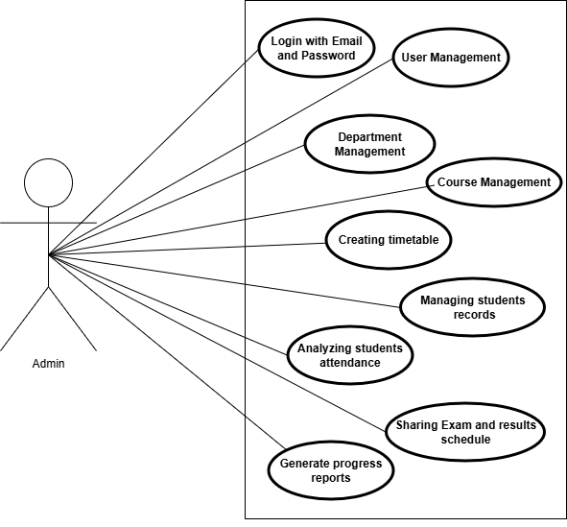
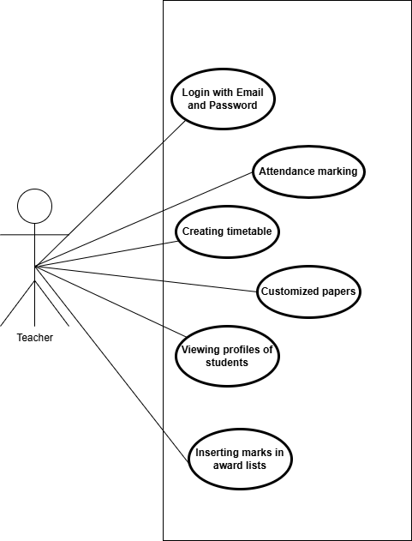
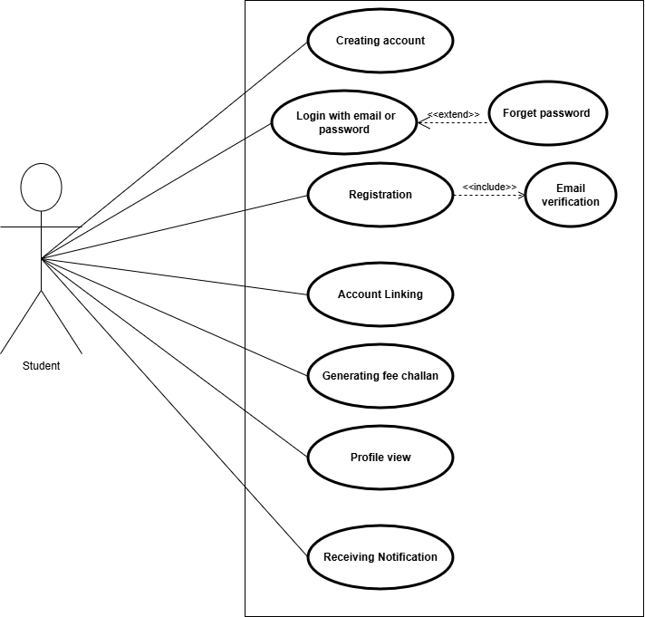

Chapter 3: System Design

Here, the system is explained from a perspective in which it operates, including dependencies and interaction with other systems.

Design Consideration

Assumptions and Dependencies:
The following assumptions and dependencies were considered: the user will have a stable internet connection, the user will have an Android 7.0+ version, the user will have Google Play Services installed, a RAM of at least 2GB, and free storage of at least 1 GB. Mostly assumptions, dependencies, and limitations were previously listed.

Risks
The risk associated with our system mainly relates to the limitations of Firebase:

Firestore allows exactly one free database per project.

Free Tire | Quota
Stored data | 1 GiB
Document reads | 50,000 per day
Documents writes | 20,000 per day
Document deletes | 20,000 per day
To address this, we adopted an approach where images are converted into Base64 String format, which provides two major benefits: first, it reduces the storage size in the database because only text-based data is saved in Firestore, and we no longer need to use Firebase Storage, only Firestore is enough. Additionally, most of the retrieved data will be cached in local storage to minimize repeated requests and reduce unnecessary read/write operations.

Requirement Traceability Matrix

Requirement ID | Requirement Description | Design Specification
FR-1 | The student shall be able to register their account using a valid email address. | Component “Authentication”
FR-2 | The student/teacher/admin shall be able to log in to their account if their email is verified. | Component “Authentication”
FR-3 | The student/teacher/admin shall be able to reset their password using email verification. | Component “Authentication”
FR-4 | The student shall be able to link their account to their Student ID, with approval by the admin/teacher. | Component “Authentication”
FR-5 | The student shall be able to generate challan forms for their college fee. | Component “User Management”
FR-6 | The student shall be able to view their personal ID details. | Component “User Management”
FR-15 | The admin should be able to add, update, and delete student records. | Component “User Management”
FR-12 | The admin shall be able to manage the user's account, like create, edit, delete, and add. | Component “User Management”
FR-7 | The student shall be able to receive notifications related to college. | Component “Notification Collection”
FR-9 | The teachers shall be able to mark the attendance of students. | Component “Attendance Management”
FR-14 | The admin shall be able to view and analyze students' attendance. | Component “Attendance Management”
FR-11 | The teachers shall be able to mark the attendance of students. | Component “Attendance Management”
FR-9 | The teachers shall be able to update award lists for midterm and sessional marks. | Component “Exam Management”
FR-8 | The teachers shall be able to update award lists for midterm and sessional marks. | Component “Exam Management”
FR-16 | The admin shall be able to schedule exams and share students' results. | Component “Exam Management”
FR-18 | The admin should be able to back up and restore system data. | Component “Backup & Restore”
FR-10 | The teacher/admin should be able to manage and update their class timetable. | Component “Timetable Management”
FR-17 | The admin should be able to add, edit, and remove courses. | Component “Timetable Management”
FR-13 | The admin should be able to add, update, and delete departments. | Component “Timetable Management”

Design Models

Class Diagrams
The following are the classes and their UML Notation diagrams, but the class relationship diagrams are added under the “UML Class Relationship” heading.

User Class
The User class will have the following attributes & methods: …………
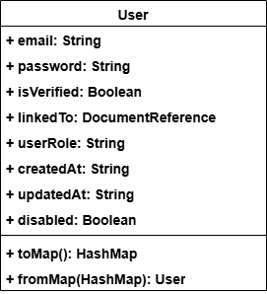

Student Class
The Student class will have the following attributes & methods: …………
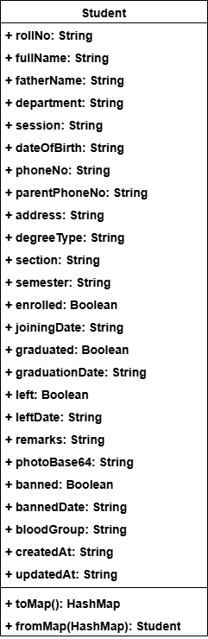

Teacher Class
The Teacher class will have the following attributes & methods: …………
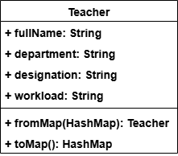

Challan Class
The Challan class will have the following attributes & methods: …………
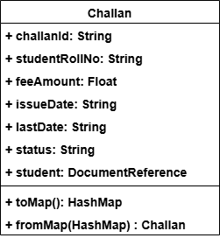

Attendance Class
The Attendance class will have the following attributes & methods: …………
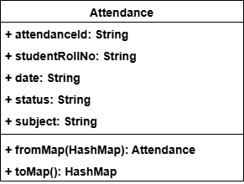

Paper Class
The Paper class will have the following attributes & methods: …………
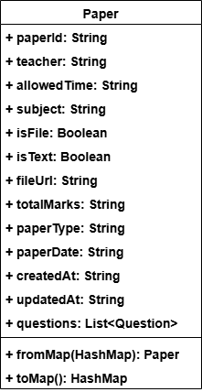

Question Class
The Question class will have the following attributes & methods: …………
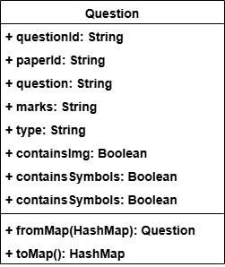

MarkSheet Class
The MarkSheet class will have the following attributes & methods: …………
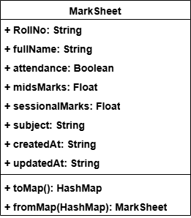

Notification Class
The Notification class will have the following attributes & methods: …………
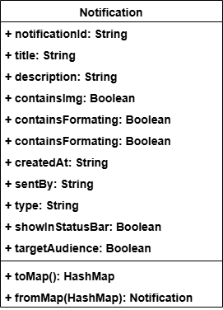

TimeTableSlot
The TimeTableSlot class will have the following attributes & methods: …………
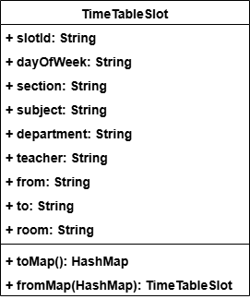

StudentRepository Class
The StudentRepository class will have the following attributes & methods: …………
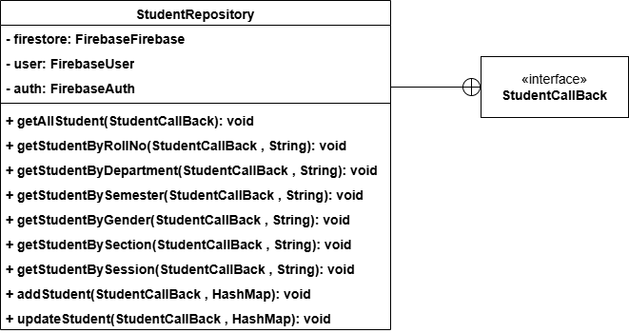

StudentCallBack Interface
The StudentCallBack Interface will have the following methods: …………
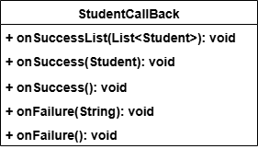

UserRepository Class
The UserRepository class will have the following attributes & methods: …………
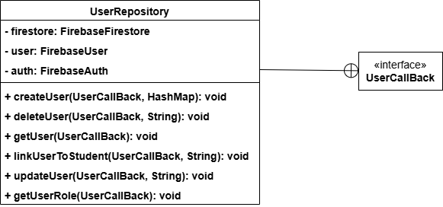

UserCallBack Interface
The UserCallBack Interface will have the following methods: …………
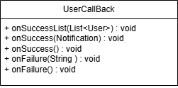

NotificationRepository Class
The NotificationRepository Class will have the following attributes & methods: …………
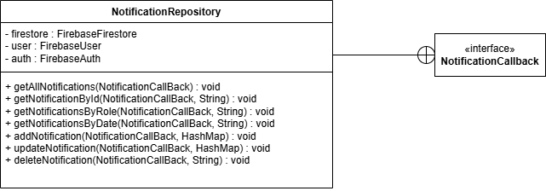

NotificationCallBack Interface
The NotificationCallBack Interface will have the following methods: …………
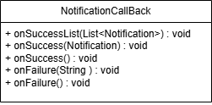

AttendanceRepository Class
The AttendanceRepository class will have the following attributes & methods: …………
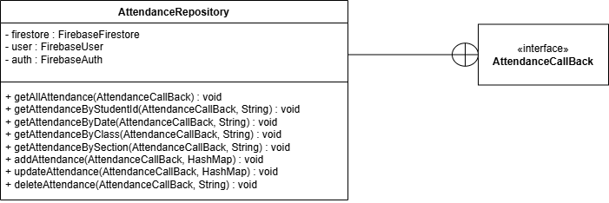

AttendanceCallBack Interface
The AttendanceCallBack Interface will have the following methods: …………
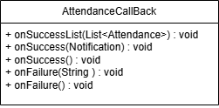

TeacherRepository Class
The TeacherRepository class will have the following attributes & methods: …………
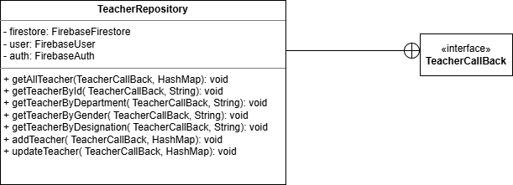

TeacherCallBack Interface
The TeacherCallBack Interface will have the following methods: …………
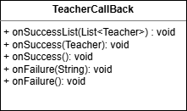

PaperRepository Class
The PaperRepository class will have the following attributes & methods: …………
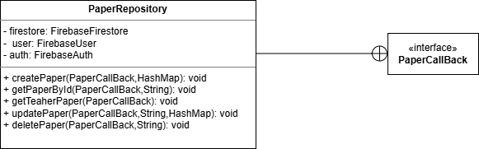

PaperCallBack Interface
The PaperCallBack interface will have the following methods: …………
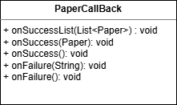

ChallanRepository Class
The ChallanRepository class will have the following attributes and methods: …………
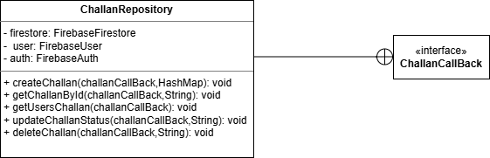

ChallanCallBack Interface
The ChallanCallBack Interface will have the following methods: …………
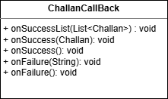

StudentAdapter
The StudentAdapter class will have the following attributes & methods: …………
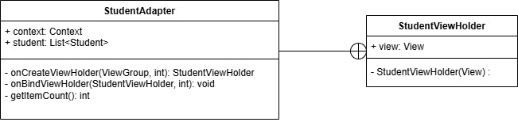

AttendanceAdapter
The AttendanceAdapter class will have the following attributes & methods: …………
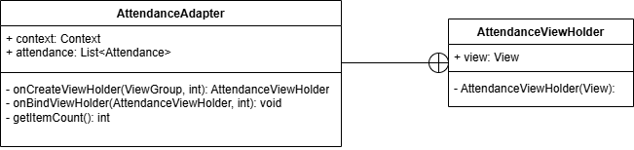

TeacherAdapter
The TeacherAdapter class will have the following attributes & methods: …………
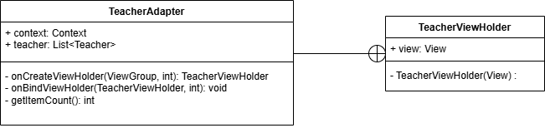

MarksAdapter
The MarksAdapter class will have the following attributes & methods: …………
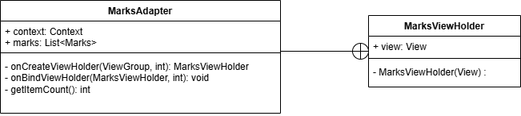

QuestionsAdapter
The QuestionsAdapter class will have the following attributes & methods: …………
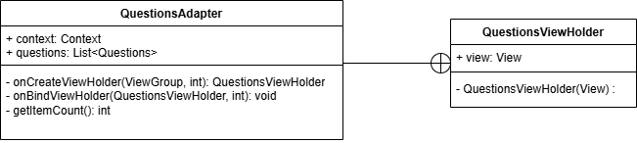

NotificationsAdapter
The NotificationsAdapter class will have the following attributes & methods: …………
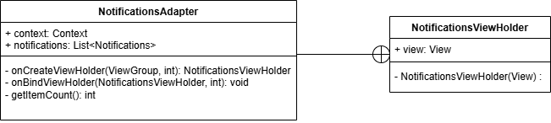

AdminsAdapter
The AdminsAdapter class will have the following attributes & methods: …………
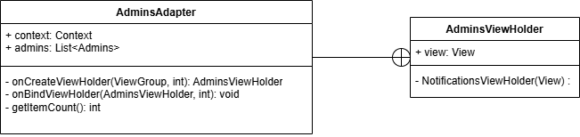

ChallanAdapter
The ChallanAdapter class will have the following attributes & methods: …………
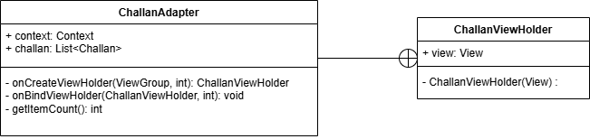

TimeTableAdapter
The TimeTableAdapter class will have the following attributes & methods: …………
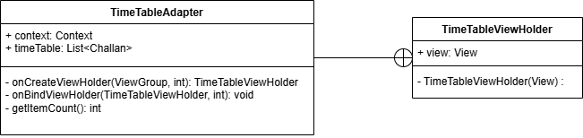

AuthenticationHelper Class
The AuthenticationHelper class will have the following attributes and methods: …………
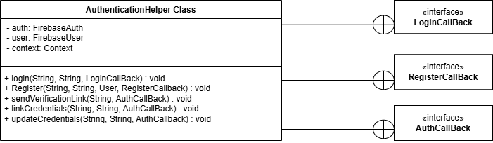

LoginCallBack Interface
The LoginCallBack Interface will have the following methods: …………
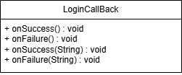

RegisterCallBack Interface
The RegisterttendanceCallBack Interface will have the following methods: …………
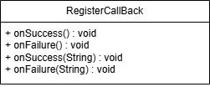

AuthCallBack Interface
The AuthCallBack Interface will have the following methods: …………
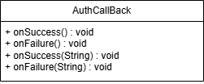

(ADMIN)

LoginActivity Class
The LoginActivity class will have the following attributes & methods: …………
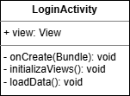

ForgetPasswordActivity Class
The ForgetPasswordActivity class will have the following attributes & methods: …………
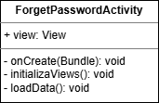

SplashScreen Class
The Splashscreen class will have the following attributes & methods: …………
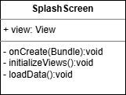

MainActivity Class
The Mainactivity class will have the following attributes & methods: …………
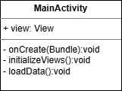

ViewClassActivity Class
The ViewClassActivity class will have the following attributes & methods: …………
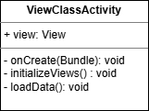

PaperSubmitActivity Class
The PaperSubmitActivity class will have the following attributes & methods: …………
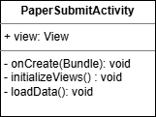

ApproveStudentActivity Class
The ApproveStudentActivity class will have the following attributes & methods: …………
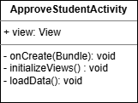

MidSessionalMarksActivity Class
The MidSessionalMarksActivity class will have the following attributes & methods: …………
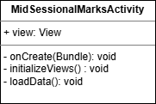

SettingsActivity Class
The SettingsActivity class will have the following attributes & methods: …………
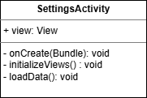

TimeTableActivity Class
The TimeTableActivity class will have the following attributes & methods: …………
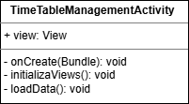

TeacherActivity Class
The TeacherActivity class will have the following attributes & methods: …………
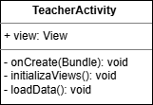

StudentActivity Class
The StudentActivity class will have the following attributes & methods: …………
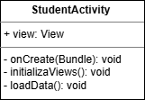

AdminListActivity Class
The AdminListActivity class will have the following attributes & methods: …………
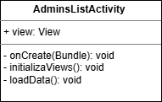

HomeFragment Class
The HomeFragment class will have the following attributes & methods: …………
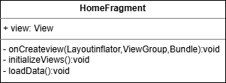

NotificationFragment Class
The NotificationFragment class will have the following attributes & methods: …………
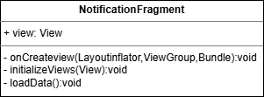

ProfileFragment Class
The Profilefragment class will have the following attributes & methods: …………
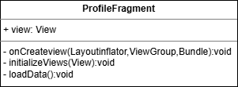

(TEACHER)

LoginActivity Class
The LoginActivity class will have the following attributes & methods: …………


ForgetPasswordActivity Class
The ForgetPasswordActivity class will have the following attributes & methods: …………


SplashScreen Class
The Splashscreen class will have the following attributes & methods: …………
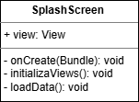

MainActivity Class
The MainActivity class will have the following attributes & methods: …………
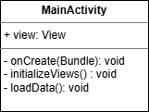

ViewClassActivity Class
The ViewClassActivity class will have the following attributes & methods: …………


PaperSubmitActivity Class
The PaperSubmitActivity class will have the following attributes & methods: …………


SendNotificationsActivity Class
The SendNotificationsActivity class will have the following attributes & methods: …………
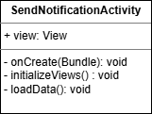

ApproveStudentActivity Class
The ApproveStudentActivity class will have the following attributes & methods: …………


MidSessionalMarksActivity Class
The MidSessionalMarksActivity class will have the following attributes & methods: …………


SettingsActivity Class
The SettingsActivity class will have the following attributes & methods: …………


HomeFragment Class
The HomeFragment class will have the following attributes & methods: …………
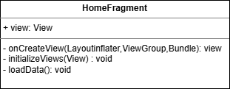

AttendanceFragment Class
The AttendanceFragment class will have the following attributes & methods: …………
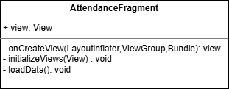

NotificationsFragment Class
The NotificationsFragment class will have the following attributes & methods: …………
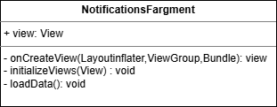

TimeTableFragment Class
The TimeTableFragment class will have the following attributes & methods: …………
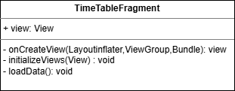

ProfileFragment Class
The ProfileFragment class will have the following attributes & methods: …………
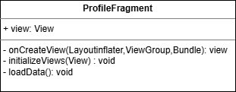

(STUDENT)

LoginActivity Class
The LoginActivity class will have the following attributes & methods: …………


ForgetPasswordActivity Class
The ForgetPasswordActivity class will have the following attributes & methods: …………


RegisterActivity Class
The RegisterActivity class will have the following attributes & methods: …………
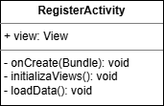

SplashScreen Class
The Splashscreen class will have the following attributes & methods: …………


MainActivity Class
The Mainactivity class will have the following attributes & methods: …………


AttendanceReportActivity Class
The Attendancereportactivity class will have the following attributes & methods: …………
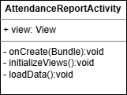

PerformanceActivity Class
The Performanceactivity class will have the following attributes & methods: …………
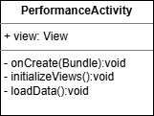

ChallanActivity Class
The Challanactivity class will have the following attributes & methods: …………
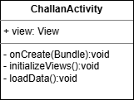

TimeTableActivity Class
The Timetable class will have the following attributes & methods: …………
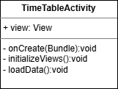

SettingActivity Class
The Settingactivity class will have the following attributes & methods: …………
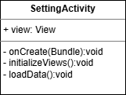

HomeFragment Class
The HomeFragment class will have the following attributes & methods: …………


AttendanceFragment Class
The AttendanceFragment class will have the following attributes & methods: …………
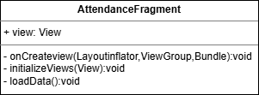

NotificationFragment Class
The NotificationFragment class will have the following attributes & methods: …………


ProfileFragment Class
The Profilefragment class will have the following attributes & methods: …………


Sequence Diagrams

Splash Screen Sequence
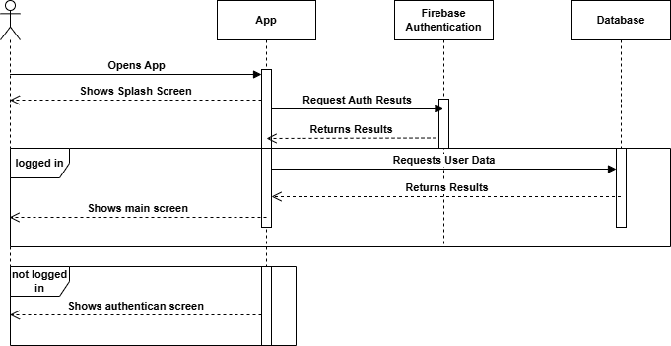

Registration Sequence
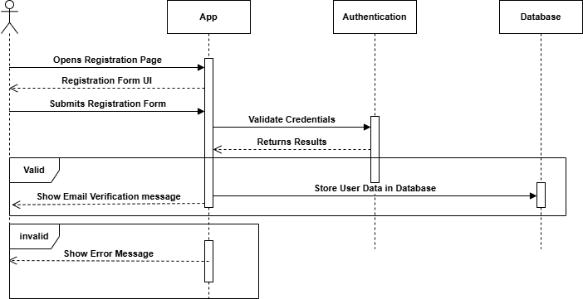

Login Sequence
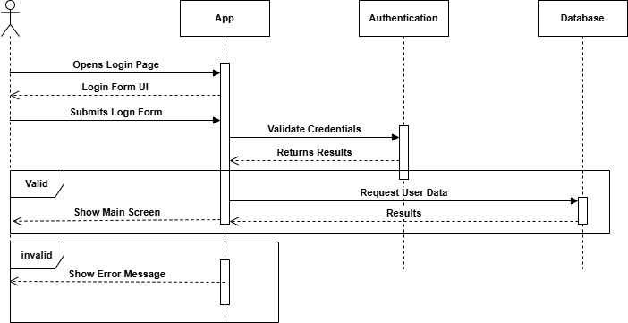

Forget Password Sequence
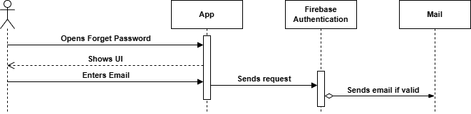

Student Account Linking Request
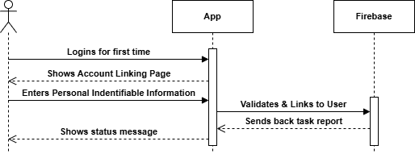

Student Challan Form Generation
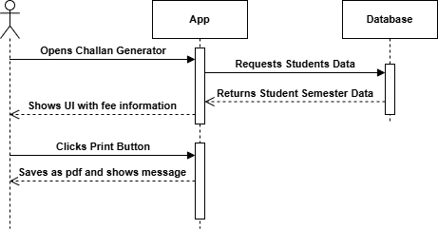

Student Account Approval
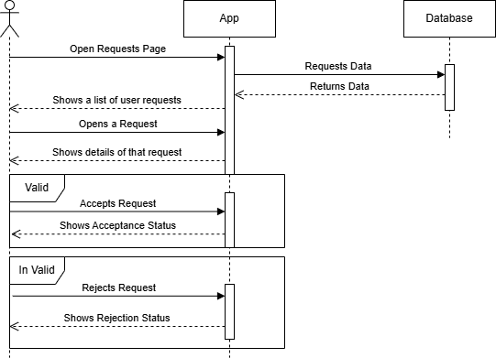

Architectural Design

Component Diagram
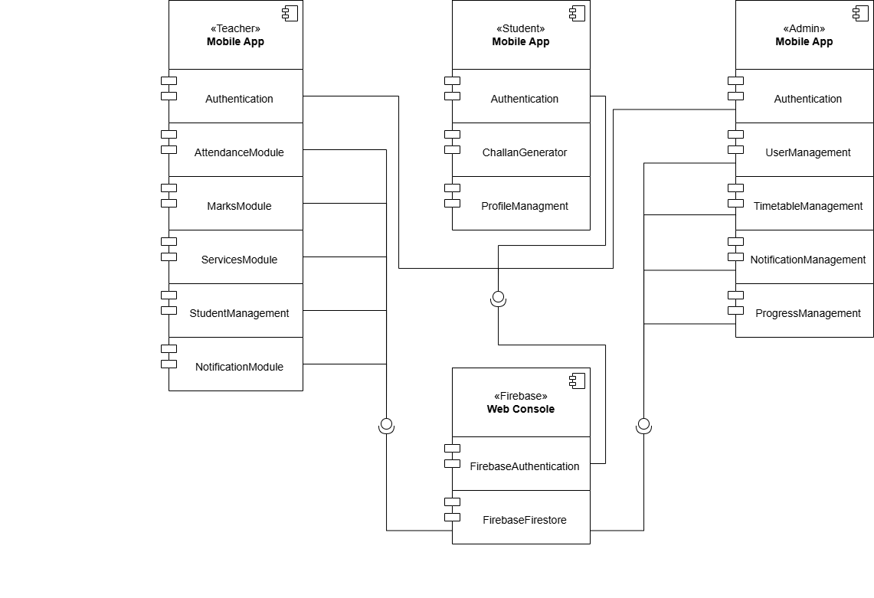

Class Relationship Diagram
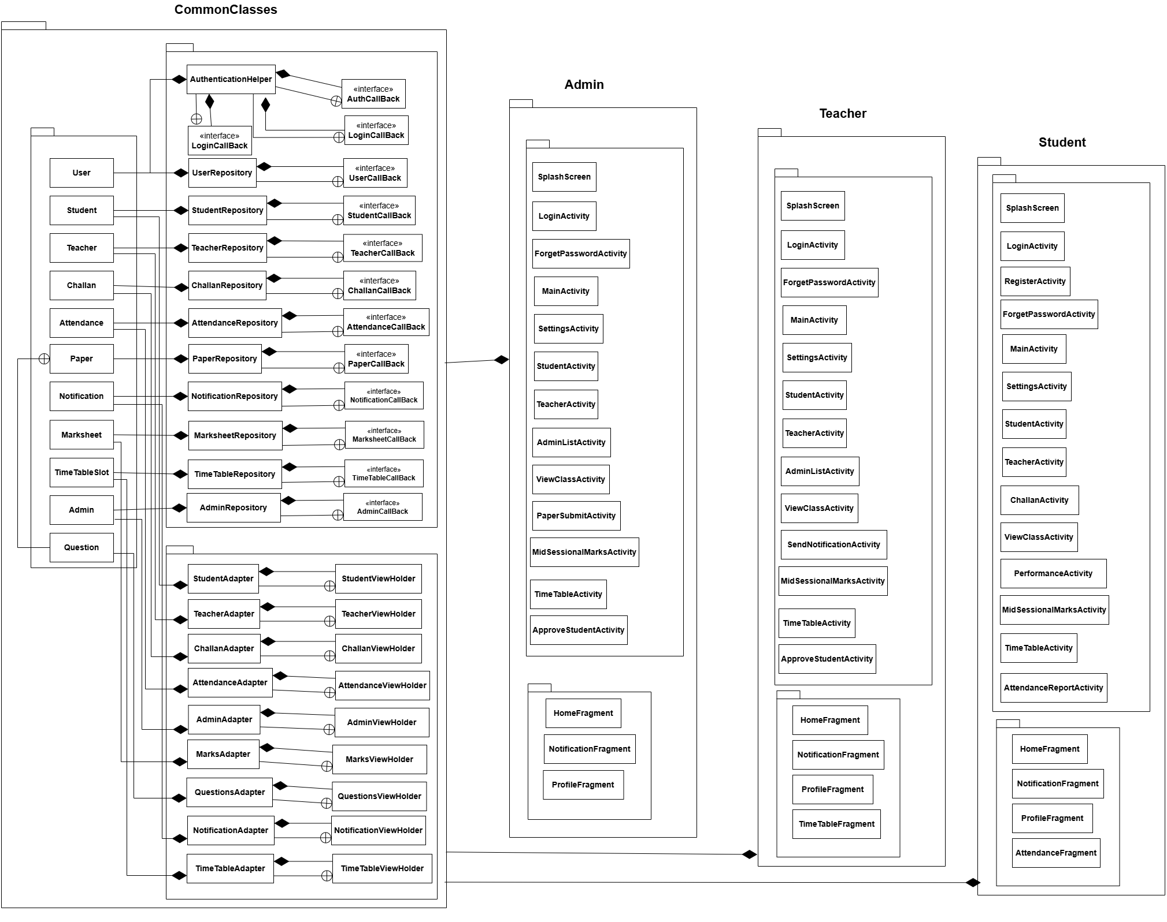

Architecture Pattern Diagram
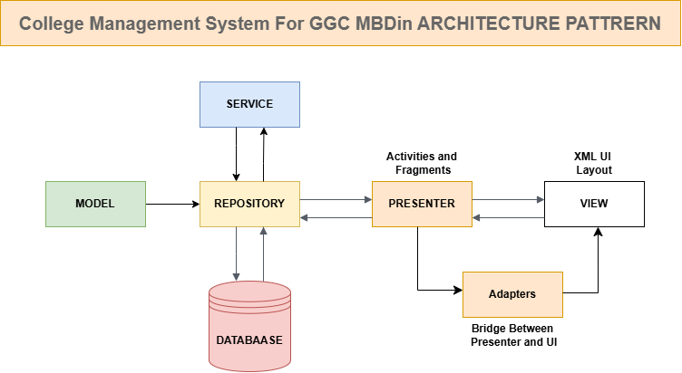

Data design
We use the List data structure to display data on the screen, such as the students list and attendance records. This data is shown in list form with the help of an Adapter.

For data storage, we use Firebase. Before storing, the data is converted into a HashMap and then saved in Firebase, which makes data storage and retrieval easy and efficient.

The Firestore hierarchy is as follows:
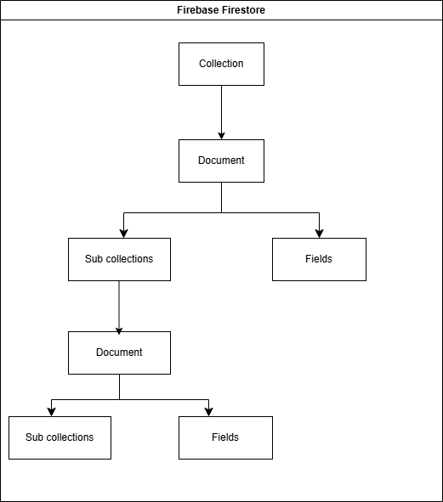
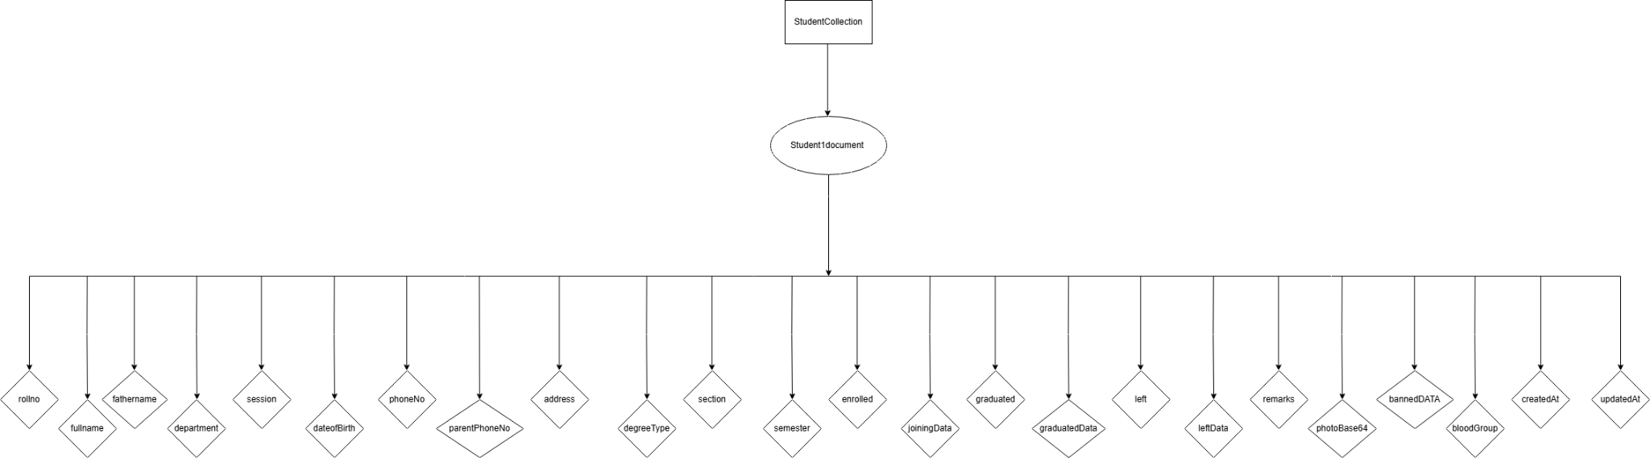

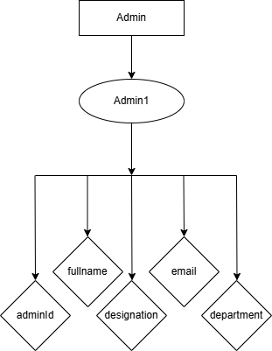
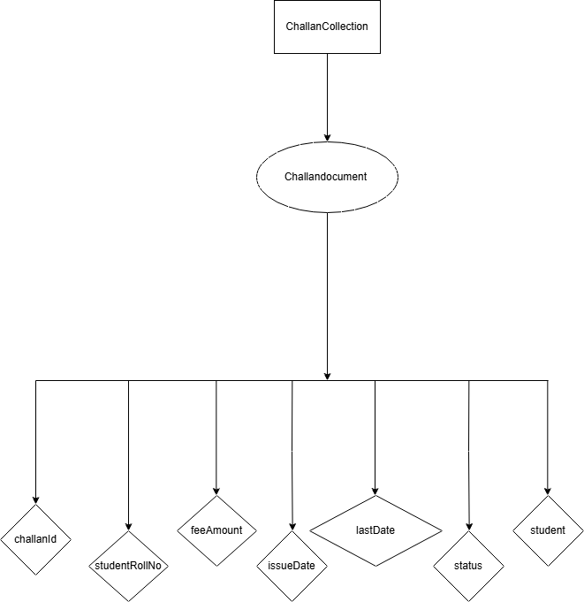

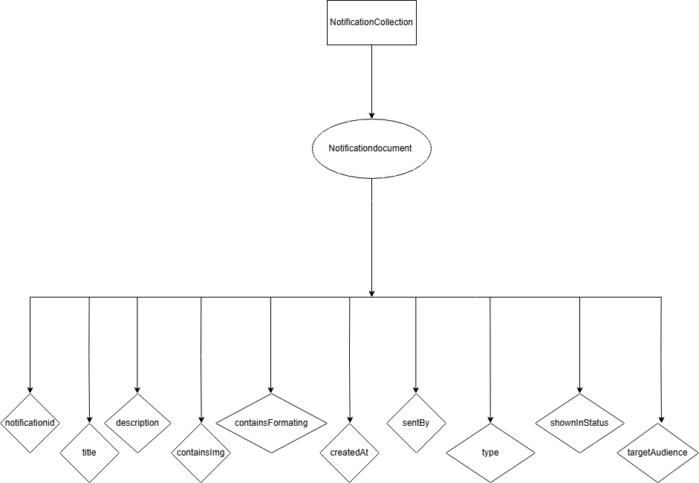
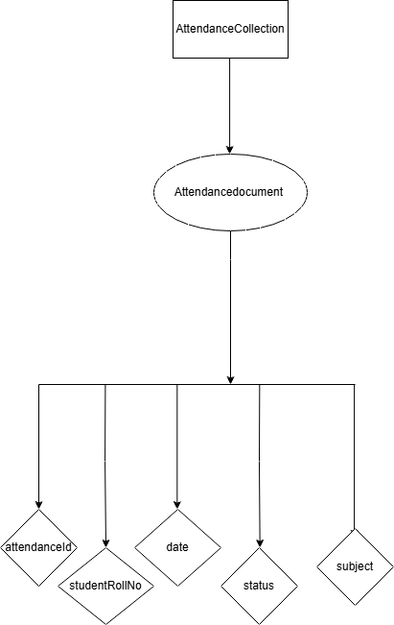
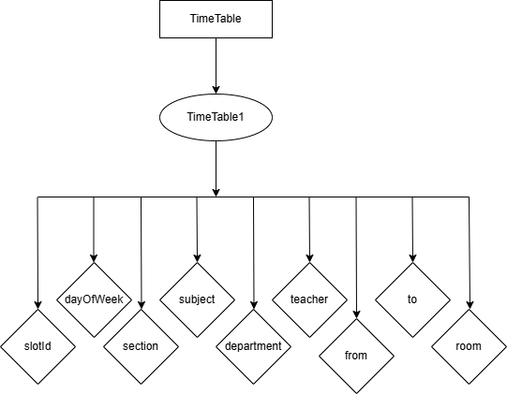
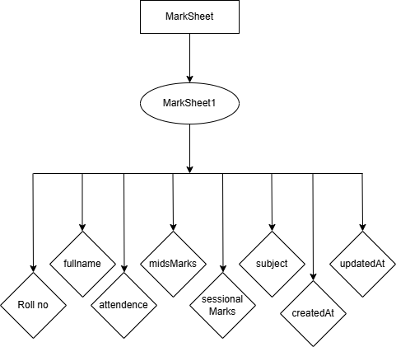
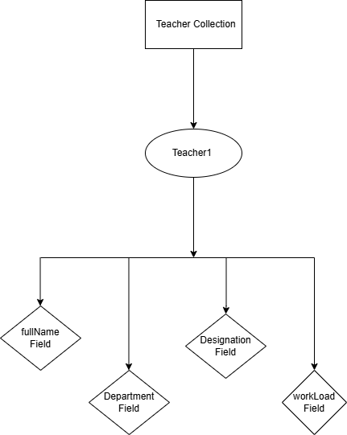
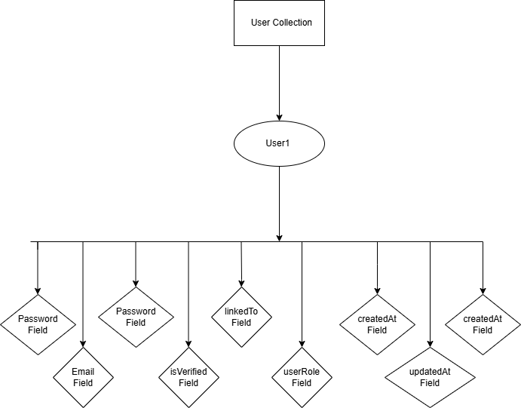
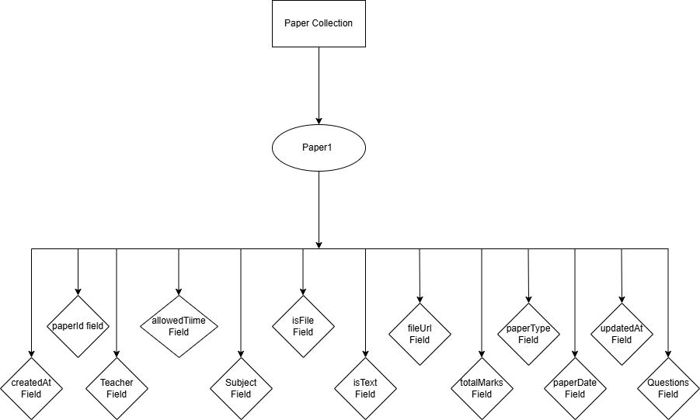
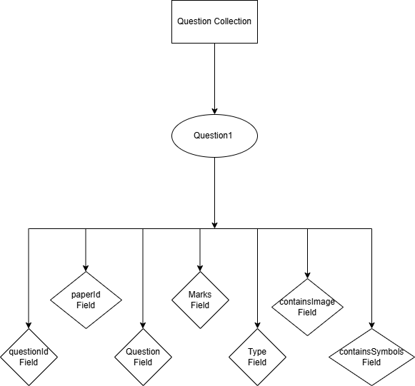

Data dictionary
Data Dictionary comprises of major classes given below:

Terminology | Description
User | Class: User class is the user's model class. The User class is used to handle common data and functionality of all users in the system.  It includes some attributes such as email, password, user role, verification status etc.
Student | Class: Student class is the student’s model class. Used to store and manage student details, including attributes such as roll no, full name, department, session etc.
Teacher | Class: Teacher class is the Teacher’s model class Used to store teacher information and manage teaching tasks such as attendance, papers, and marks, including attributes such as full name, department, designation, workload.
Attendance | Class: Attendance class is the Attendance’s model class used to store daily attendance records of students for each course or class session, including such as attributes, attendance, date, status etc.
Challan | Class: Challan class is the Challan’s model class used to store fee-related details for each student, including amount, due date, and status, including attributes such as challanid, studentRollno, feeamount etc.
Paper | Class: Paper class is the paper’s model class used to store exam paper details created by teachers, including question list and paper information, including attributes such as  paperid, teacher, allowedTime etc
Question | Class: Question class is the question’s model class used to store individual question details, marks, and question type inside a paper, including attributes such as questionid, paperid, marks etc
Marksheet | Class: Marksheet class is the Marksheet’s model class Used to store subject-wise marks, grades, and overall performance of a student, including attributes such as Rollno, fullName, attendance etc.
Notification | Class: Notification class is the notification’s model class Used to store system announcements or messages sent to students and teachers, including attributes such as notificationid, title, description, containsImg etc.
TimeTableSlot | Class: TimeTableslot class is the Timetable slot’s model class Used to store details of a single class timing, including day, time, room and assigned teacher and course, including attributes such as slotid, dayOfweek, section etc.
StudentRepository | Class: StudentRepository class is the student’s model class Used to fetch, store, update and delete student data from the database, including attributes such as Firestore, user and auth.
StudentCallBack | Interface: Interface used to receive responses when student related operations are performed, including attributes such as
UserRepository | Class: UserRepository class is the user repository’s model class Used to manage user login, signup, authentication and user details through database, including attributes such as Firestore, user and auth.
UserCallBack | Interface: UserCallBack is used to receive success and error responses for user related processes.
NotificationRepository | Class: Notification repository is used to manage notification data such as saving, fetching, and updating notifications in the database, including attributes such as Firestore, user and auth.
NotificationCallback | Interface: Notification Callback is used to handle the response of notifications, for example when a notification is sent, received, or fails.
AttendanceRepository | Class: Attendance Repository is used to manage attendance data, such as saving, updating, and retrieving attendance records from the database.
AttendanceCallback | Interface: Attendance Callback is used to handle the response of attendance operations, for example when attendance is marked successfully or when an error occurs.
TeacherRepository | Class: Teacher Repository is used to manage teacher data, such as adding, updating, deleting, and retrieving teacher records from the database.
TeacherCallBack | Interface: Teacher Callback is used to handle the response of teacher-related operations, for example when data is fetched successfully or when an error occurs.
PaperRepository | Class: Paper Repository is used to manage paper data, such as adding, updating, retrieving, and deleting exam papers in the system.
PaperCallBack | Interface: Paper Callback is used to handle the response of paper-related operations, for example when a paper is uploaded successfully or when an error occurs
ChallanRepository | Class: Challan Repository is used to manage challan data, such as generating, updating, and retrieving fee challans from the database.
ChallanCallBack | Interface: Challan Callback is used to handle the response of challan-related operations, for example when a challan is generated successfully or when an error occurs.
StudentAdaptor | Class: StudentAdaptor takes student data in the form of a list and displays that list of students on screen. An adapter works as a bridge between UI and the activity or fragment.
AttendanceAdaptor | Class: AttendanceAdaptor takes attendance data in the form of a list and displays that list of student’s attendance on screen. An adapter works as a bridge between UI and the activity or fragment.
TeacherAdaptor | Class: TeacherAdaptor takes teacher data in the form of a list and displays that list of teacher’s data on screen. An adapter works as a bridge between UI and the activity or fragment.
MarksAdaptor | Class: MarkAdaptor takes marks data in the form of a list and displays that marks list on screen. An adapter works as a bridge between UI and the activity or fragment.
QuestionAdaptor | Class: QuestionAdaptor takes question data in the form of a list and displays that question list on screen. An adapter works as a bridge between UI and the activity or fragment.
NotificationAdaptor | Class: NotificationAdaptor takes notification data in the form of a list and displays that notification list on screen. An adapter works as a bridge between UI and the activity or fragment.
AdminAdaptor | Class: AdminAdaptor takes admin data in the form of a list and displays that admin list on screen. An adapter works as a bridge between UI and the activity or fragment.
ChallanAdaptor | Class: ChallanAdaptor takes challan data in the form of a list and displays that challan list on screen. An adapter works as a bridge between UI and the activity or fragment.
TimeTableAdaptor | Class: TimetableAdaptor takes timetable data in the form of a list and displays that timetable list on screen. An adapter works as a bridge between UI and the activity or fragment.
AuthenticationHelperClass | Class: AuthenticationHelper is a helper class that handles all authentication tasks using firebase. It includes the attributes such as FirebaseAuth auth, FirebaseUser user, Context context.
LoginCallBack | Interface: This interface is used to handle login results. It sends a login success or failure response back to the activity or Fragment.
AuthCallBack Interface | Interface: This interface is used for authentication related actions like, Email verification, Updating credentials, Linking accounts. It returns the result of authentication actions to the UI.
RegisterCallBack | Interface: This interface is used to handle users registration results. It informs the UI whether user registration was successful or not.
LoginActivity | Class: LoginActivity is responsible for handling the user login screen . Manages user login UI and interaction. It includes the attribute View view.
ForgetPasswordAcitivity | Class: ForgetPasswordActivity handles the Forgot password screen . Allow users to reset or recover their password It includes the attribute View view.
SplashScreen | Class: SplashScreen is the first screen shown when the app opens. Displays app logo and checks initial condition . It includes the attribute View view.
MainActivity | Class: MainActivity is the main screen of the application. It includes the attribute View view. Controls the main app interface and core features.
ViewClassActivity | Class: ViewClassActivity is used to display class related information. It includes the attribute View view. Show class details to the user.
PaperSubmitActivity | Class: PaperSubmitActivity handles paper or assignment submission. It includes the attribute View view. Allow users to submit papers or assignments.
SendNotificationActivity | Class: SendNotificationActivity handles sending notifications to users. It includes the attribute View view. Allow admin teacher to compose and send notifications to selected users.
ApproveStudentActivity | Class: ApproveStudentActivity is used for approving student requests. It includes the attribute View view.
MidSessionalMarksActivity | Class: MidSessionalMarksActivity handles mid-session marks entry or display. It includes the attribute View view. Manages mid sessional marks for students.
SettingsActivity | Class: SettingsActivity manages the app settings screen.. It includes the attribute View view. Allows the user to change application settings.
TimeTableActivity | Class: TimetableActivity handles the class timetable screen.. It includes the attribute View view. Displays and manages the timetable
TeacherActivity | Class: TeacherActivity Manages teacher related information. It includes the attribute View view. Displays and manages the teacher data.
StudentActivity | Class: StudentActivity manages student related screens. It includes the attribute View view. Displays and manages the student data.
AdminListActivity | Class: AdminListActivity shows the list of admins. It includes the attribute View view. Displays admin users list
HomeFragment | Class: HomeFragment is the home screen fragment inside an activity.It includes the attribute View view. Displays the home content of the app.
AttendanceFragment | Class: AttendanceFragment shows attendance of student. It includes the attribute View view.
NotificationFragment | Class: NotificationFragment shows user notifications. It includes the attribute View view. Displays notifications to users.
ProfileFragment | Class: ProfileFragment shows user profile information. It includes the attribute View view. Display and manages user profile.
TimeTableFragment | Class: TimeTableFragment shows class timetable inside activity.It includes the attribute View view. Shows the schedule of class, lectures, or exams in calendar or list format
RegisterActivity | Class: RegisterActivity handles new user registration. It includes the attribute View view. Allow new user to register in the app.
AttendanceReportActivity | Class: AttendanceReportActivity manages attendance reports. It includes the attribute View view. Display student’s attendance records in a report format.
PerformanceActivity | Class: PerformanceActivity handles student or teacher performance data. It includes the attribute View view. Show marks grades or other performance metrics.

Terminology
Description

Designs Decisions
We are using Android Studio for App development, and our project will consist of four Android Studio modules: One module for common classes like model classes, repository classes interacting with Firebase Firestore, authentication classes, adapter classes, and other such utility classes. Second, third, and fourth modules will contain activities, fragments, and design layouts for Student, Teacher, and Admin Apps.
The Architecture of the application is MVP, which is Model View Presenter. Which is not MVC (Model-View-Controller). The implementation of MVP is much easier, and testing is also considerably easier compared to MVC.
The use of interface classes, such as Callback interfaces, is used for asynchronous programming, as Firestore and Authentication-related classes require an internet connection to complete their tasks.
The Firebase Database and Authentication were chosen because of familiarity and easy integration, and easy understanding for upcoming sessions if they want to make some changes
To simplify the interaction with Firebase Firestore, each collection's related methods are summed in its repository class.
For our college management system, we are using MVP architecture. We select this pattern because it is simple to understand, easy to maintain, and helps to keep the code of the application organized. With MVP, the system becomes more modular, meaning all the modules, admin, teacher, and student can work independently without affecting each other. This pattern also makes testing and updating easy.
For the database, we are using a Firebase free version with a room database. Firebase is a cloud-based NoSQL database that works very well with Android apps and is simple to integrate.
Firebase authentication is used for logging in Admins, teachers, and students. Cloud Firebase to store important data such as profiles, attendance, etc. Real-time database for features that need instant updates, like live attendance marking. We are using Firebase Cloud Messaging to send notifications. Firebase Storage requires a paid plan. Instead, we convert images into Base64 format and save them as text in Firebase. This allowed us to store images without paying for Firebase Storage. We also used a room database to store some data locally on the device. This helps the app work even when the internet is slow or not available. Users can see the required information offline without waiting for Firebase to load or without waiting for an internet connection.
For development, we use Android Studio, which is a tool for developing apps. We are using Java because many apps are developed using Java, and it is reliable.
In our College Management System, we used web-based forms and interfaces for the Admin module to make data easy to view and manage. All information in the Admin Web Panel is displayed using tables, input fields, and structured layouts.

User Interface Design

Screen Images
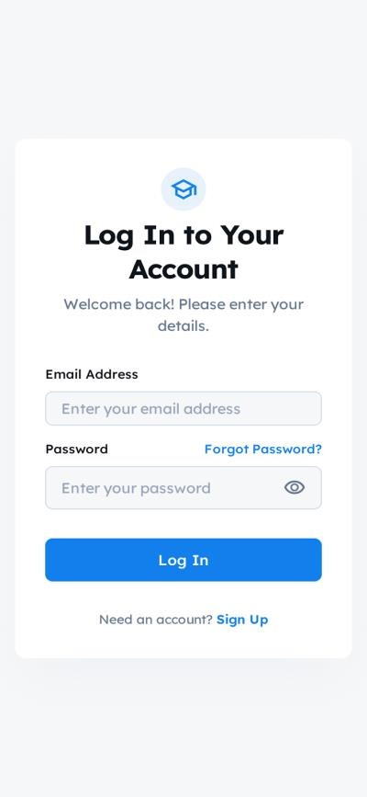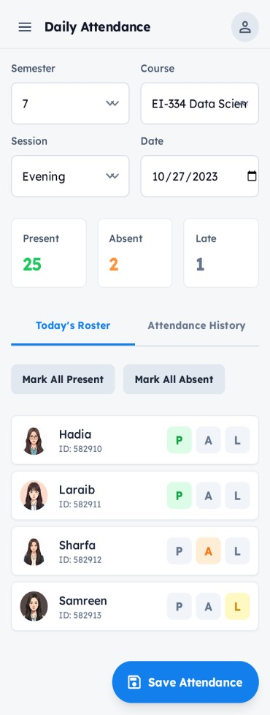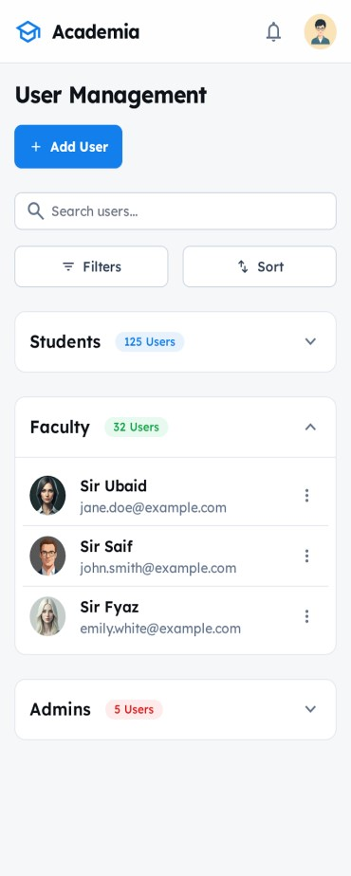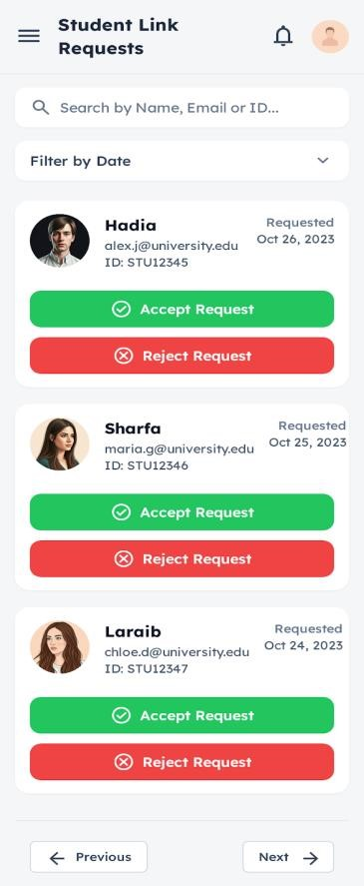

Summary
This chapter presents a detailed analysis of the system design, covering design considerations, architectural structure, and high-level abstract models. It includes sequence, state, class, and component diagrams. The MVP architecture pattern is used for its simplicity and ease of testing.

References
- Ellucian. (2023). Student Information System (SIS): Higher education solutions. Retrieved from https://www.ellucian.com
- University of Sargodha. (2023). Student Self Service Portal. Retrieved from https://su.edu.pk
- Punjab University. (2023). Examination Result Portal. Retrieved from http://pu.edu.pk
- Husnain, M. (2025). SOWProgramming – YouTube Channel (Lectures and FYP Guidelines). Retrieved from https://www.youtube.com/@SOWProgramming
- Husnain, M., Ramazan, M., & Ali, S. (2025). SOWProgramming - An Intelligent E-Learning Platform. Retrieved from https://play.google.com/store/apps/details?id=com.sowp.user

